Geography Case Studies

A country which is over-populated - Kuwait
Causes
- 1938 – huge oil reserves discovered in Kuwait = economic growth and prosperity
- Oil now accounts for half of the country’s GDP & 94% of its exports
- 1950 – population = 152,000
- 2016 – population = 4,348,000
- In 2017, Kuwait had the 5th highest per capita income in the world of $73,017
- Migrant labour responsible for a lot of this growth – 69% of total population in 2016
- 2016 – population density = 236 people per km² which would be 10 people per km² without the oil

Consequences
- Water shortages – hot summers and low precipitation rates, no permanent rivers and insufficient sources of ground water sources
- Country is the most arid in the world but water consumption per capita are among the world’s highest – daily use of 550 litres per head (double the word average)
- Government relies on desalinisation to provide industry and households with fresh water – costs $2 billion annually
- Kuwait consumes 4 times the electricity of HICs such as the UK due to desalination of seawater and air conditioning.

A country which is under-populated - Australia

Case study: Underpopulation in Australia
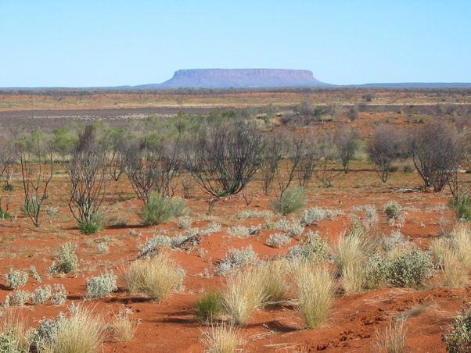
What is Underpopulation?
If the number of people living in an area is less than needed to make full use of the resources available then the area can be described as underpopulated.

Australia has many resources but it is not using them fully. The country could support a higher population, which means that it is underpopulated.

Area and facts:
- Australia has a population of 22.5 million and is a similar size to the USA. However the USA has 300 million people living in it.
- Population is 22.5 million with a population density of 2.9 per square kilometre, the lowest in the world
- Many areas of Australia are empty and it could support a higher population.Only 10% of the land is inhabited
- Successive governments have tried to increase its population, to develop the country economically and to protect it from foreign influence.
- Natural population growth rate is 0.6%
- Most live on coast as interior is desert
- There is a huge potential for solar and wind power

What problems has underpopulation caused in Australia?

• Shortage of workers which has led to lower optimum productivity. Boston Consulting Group has released a report predicting a shortfall of 2.3 million workers by 2030.
to develop the country economically, Australia started to attract migrants from other countries which raised the Population to 23 million from 3.7 million in 1901.

27% net migration 2016-2017
• Conflicts caused in major cities such as Sydney by need to attract foreign workers.
• Not possible to exploit all resources and large areas of outback undeveloped/underutilised. Northern territory is rich with energy, agriculture, business and other industries, and has vibrant and growing communities but remains under-utilised relative to the rest of Australia, despite its natural, geographic and strategic assets
• Less people paying tax. 43% of the labour force will be due to retire in next 20 years. Taxes will have to be raised to fund retirement. Australia's tax take from individuals and businesses is one of the highest in the developed world, high taxes are levied on the lower and middle income earners and higher income earners are thinking of overseas relocation
• Schools and hospitals may close because there are not enough people to support them.
• Public transport links might close because of less customers. It is unlikely that new transport systems will develop as there is not enough people to support them. This increases peoples reliance on cars
• There may be less innovation and development.
• Hard to defend country.

A country with a high rate of natural population growth - Bangladesh
The 2011 census puts the population of Bangladesh at 150.6 million, reflecting an increase of more than 20 percent over the 2001 census population levels
1.6% growth rate (2015 est.)
Birth rate | 21.14 births/1,000 population (2015 est.)
Death rate | 5.61 deaths/1,000 population (2015 est.)

Why is the population grow rate high? Causes of high rates of natural population growth
1. 56% of the women in Bangladesh are in the reproductive age group of 15–49 years.
2. Another 31% of the population is below the age of 15 years and will soon be entering the reproductive life span and contributing to the increasing numbers.
3. FERTILITY RATE: From extremely high levels of 6.3 in 1975, to 3.3 in the year 2000, the TFR now stands at 2.3 according to the Bangladesh Demographic and Health Survey 2011, which is still some distance away from replacement fertility levels (2.1)
4. There is a general lack of availability and knowledge regarding contraceptives which leads to a high birth rate. Only 61.2% contraceptive use in 2011. There exists an urban-rural divide in the use of contraception with 52% of the urban women using a modern method of contraception compared to only 46% of the rural women.
5.17% of all married women have an unmet need for family planning due to lack of access
6.: Bangladesh has a high adolescent fertility rate, one of the highest amongst the SEAR nations and a lower uptake of contraceptives in this age group
7. Large proportion of population work as subsistence farmers and children are regarded as an economic asset and therefore people have lots of children to help them work on the farms.
4. There is no state pension system in Bangladesh, so people also have lots of children with the hope that their children will take care of them when they are too old to work and provide for themselves.
5. Bangladesh is a poor country (GDP per capita is approximately $240.00), which lacks suitable medical facilities and vaccinations. IMR (Infant Mortality Rate) is therefore high and so people have lots of children to replace those that die at a young age.
6. Females are not fully emancipated which is another contributory factor to the country having a high birth rate.

A country with a low rate of population growth (or population decline) Singapore
- Post WW2 – anti-natalist policies introduced to slow and reverse the boom in births.
- Publicity campaigns ‘stop at two’ – big families seen to threaten living standards (unemployment, housing shortages, and increasing resource use), education, healthcare and political stability.

- 1980 – government reversed this policy as birth rates had fallen below replacement levels. Pronatalist policies then introduced.
- New publicity campaign – ‘Have three or more if you can afford it’.
- A new package of incentives for large families included:
- Tax rebates for having a 3rd child
- Up to 4 years unpaid maternity leave for civil servants
- $20,000 tax rebate for 4th child born after 1988
$100 subsidy per month for childcare
- Third-child families given priority over smaller families for school registration

Outcome
- Fertility rose from 1.4 in the early 1980s to 1.96 in 1986 – but still below replacement level
- Government introduced a baby bonus scheme – when more than one child was had, a Children development fund was set up – the government put in up to $1000 per year (matching parents’ contribution), to help fund education of the child.
- Singapore’s population was just 5.77 million in 2015 and fertility rate just 1.24.
- The government have now more strongly encourage immigration to make up the numbers.

Government population policy - China one child policy
- The most populated country in the world – 1.4 billion
- 1979 – ‘One child policy’ introduced due to food shortages/ pressures on resources-
these measures included:
- Just one child per couple
- Men could not get married until 22 and women 20
- Couples had to apply to get married and then again to have a baby
- One child reward – 10% pay increase, free education, family benefits, priority housing
- Those who did not conform lost all benefits and paid huge fines
- In 1999. Families in rural areas were allowed to have two children
Negatives

- Sex-selected abortion as boys valued more than girls. Baby girls abandoned on the streets – ‘China’s little emperors’ – a generation of spoilt children.
- Gender imbalance – more boys than girls – 30 million men struggle to find partners
- Rural areas struggled as children seen as economic assets – labour on farms etc.
- Ageing population and shrinking labour force – by 2050 – China will gave 440 million over the age of 60

Positives

- The average number of children per woman in China dropped from 6 to 2.5 . Between 1950 and 2005, the birth rate dropped from 44 per 1000 to 14 per 1000.
- It has prevented 400 million births easing pressure on resources

Changes

- Jan 2016 – policy abandoned and changed to two-child policy in response to ageing population

An international migration - Mexico - USA
Causes of migration
BPP  Push and Pull factors  - Employment  - Education  - Amenities  - Bright lights effect  - Violence (gangs)  - Rural – urban  - Proximity  - Demand for low skilled manual work | Development and case study information  - High wages (GNP per capita – Mexico $12,000 and USA $57,000) and higher employment (unemployment – Mexico 22%, USA 4%)  - Public schools better in USA  - Better leisure options + better infrastructure  - Perception that life is better through Hollywood and TV shows  - Drug violence (cocaine trade) makes Mexicans feel unsafe (Cuidad Juarez considered one of the most dangerous cities in the world)  - Some Mexicans move after collapse of subsistence farming  - US – Mexican border is close and easy to cross without a visa  - Seasonal farm workers attracted by short term employment. Mexicans prepared to do low paid work (or dirty work – e.g. maids)
Impacts on destination country (USA) – also called host country
- Labour costs decline  - Skill shortages plugged  - Multiculturalism  - Unemployed locals  - Increased pressure on housing and services  - Racism + tension | - Business thrive as wages are reduced  - Doctors and nurses employed to fill gaps  - Shared culture – Cinco de Mayo becomes a big US holiday  - Less jobs available for local Americans as Mexicans (Latinos) take low paid jobs  - Housing prices increased and public services are more expensive  - Some Mexicans struggle to integrate encouraging racism and isolation.
Impacts on origin country (Mexico) – also called losing country
- Remittances  - Reduced employment pressure  - More housing and public services  (but less investment)  - Brain drain  - Mexicans return with changed values | - $25 billion returned to Mexico from workers in USA  - Unemployment reduced as people leave  - Less pressure on free health service (IMMS) and amenities. Although many old people left behind who often use it more  - Loss of skilled workers – especially doctors who are in high demand in USA  - English now widely spoken in Northern states. Baseball widely played in Northern states (LMB – Durango Generals)

A country with a high dependent population - youthful dependents – Somalia
- Located in east Africa (Horn of Africa)
- 2016 – population = 11.1 million & 2021 = 15 million
- Rapidly expanding population with 3% annual growth
- High fertility rate 6.26 children per woman (4th highest0
- Somalia has a classic triangular population pyramid with the concave shape typical to LICs
- The wide base shows the high birth rate. The sloping concave sides show that the death rate is high in all age groups.
- Life expectancy is low (54 years) and infant mortality rates are very high (72 deaths per 1000 live births). This is shown by a marked reduction in the population at the 0-4 and 5-9 age groups.

Problems

- The government are concerned as to whether food production will keep up with the growth in the population
- Will there be enough employment for all the young people when they reach working age?
- Will there be enough money from taxes to pay for education and healthcare of such a large dependent population?
- Education is limited and schools have basic materials. Few children attend, especially in rural areas.
- Unclean drinking water, poor sanitation and malnutrition are significant problems.
- Many preventable diseases such as cholera and malaria are widespread, especially in rural areas where 60% of the people live.

A densely populated country or area (at any scale from local to regional) - The Ganges river basin
- The Ganges river has the second greatest water discharge in the world, after the Amazon.
- It is the most heavily populated river basin in the world, with an average population density of 1000 people per km2.
- The Ganges river basin is extremely important to the people of India, Nepal, China and Bangladesh which it runs through and many people live beside it using it for bathing and fishing.
- The south-west monsoon winds bring precipitation to the Ganges River basin from July to October. It also comes from cyclones that originate in the Bay of Bengal.
Farming
- The huge floodplain of the river Ganges is rich in alluvium and produces fertile soils so is important for agricultural economies of India and Bangladesh. This area is intensively farmed.
- The water is also used for irrigation. 90% of the water withdrawn is used for agriculture and 8% for domestic use. A wide range of crops are cultivated including rich, sugar cane, lentils, oil seeds, potatoes, and wheat. These crops support millions of people.
- 580,000km2 of the Ganges River basin is arable land.
HEP
- The HEP potential of the Ganges is huge and India uses 12% of that potential.

Pollution
- Human and industrial waste from such a large population has caused pollution of both surface water and ground water.
- Raw sewage is dumped into the river and people bathe and use the river to clean laundry.
- Fecal coliform bacteria is 3000 times higher than what is considered safe in some areas
- This impacts on the quality of water
- Over-abstraction of water has threatened the quantity of water available for such a large population

A sparsely populated country or area (at any scale from local to regional) - Mongolia
Background/ facts
- Mongolia is in the centre of Asia and is one of the world’s most sparsely and underpopulated countries.
- It has a population density of just 1.94 per km²
- The country has large mineral resources which could support a large population, but its climate is extreme and locate remote.
- One of the largest countries in the world which is landlocked – border Russia to the north and China to the East, South and West
Physical reasons for low population density
- Relief - Mongolia consists of a high plateau – 900-1500m in height
- It has vast areas of semi-desert and desert plains, grassy steppe, mountains in the west and south-west and the Gobi desert in the south central area
- Climate – extreme continental climate with long extremely cold winters and short hot summers – temperature range of -50’C (mountains) to 40’C (Gobi Desert).
- The annual average temp in the capital city of Ulaanbaatar is -1.3’C – the world’s coldest capital city#
- Ulaanbaatar has 45% of Mongolia’s population
- Short growing season – just 90 days this combined with sharp falls in temperature and frosts make agriculture difficult
- 30% of families make a living from breeding livestock – this accounts for 85% of Mongolia’s agricultural output. Herding families are self sufficient in meat and milk products and earn a living from selling animals, milk, meat, skins, hides, sheeps’ wool and cashmere wool.
- Severe winters such as 2009-2010 can cause death to livestock – 22% lost

Human factors
- Summer droughts and cold winters kills livestock forcing many people to migrate to urban areas
- Over-grazing – damage to soil as goats reared for cashmere as their wool gains a higher price
- Rural areas lack basic infrastructure – the government have now put in place water wells, weather warnings and compensation for lost animals.
- Minerals now represent 80% of Mongolia’s exports – however jobs in the mining industry are dependent on the world prices of the minerals and changes can have a huge impact om the economy and population
- Remote - Mongolia only has 4800km of paved roads so moving around the country is not easy – most roads are gravel roads or cross-country tracks

Settlement and service provision in an area – South Cambridgeshire
Case study: settlement hierarchy and service provision in an area: South Cambridgeshire

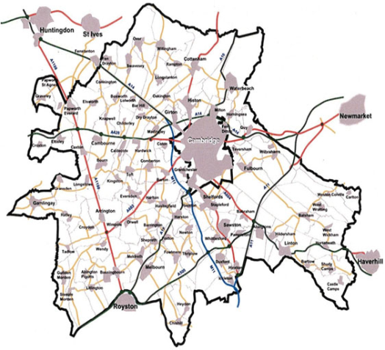

Settlement hierarchy
- Cambridge is the single main city of S Cambridgeshire. It has a population of 130,000
- It has 5 towns within a 10 mile radius, 3 of which are actually outside the borders of Cambs. Royston (Herts), Haverhill and Newmarket (Suffolk)
- It has over 50 villages and over 150 hamlets and its sphere of influence extends farthest to the East where the nearest city is Norwich over 60 miles away. It’s theatre and shops attract visitors from all over south Cambridgeshire while in a sense it has a global sphere of influence due to its tourist attractions
- Although it is smaller than Peterborough (pop 183,700) Cambridge has a bigger sphere of influence as it has a much higher proportion of high order services and more significant educational, historical and cultural functions

Service provision and hierarchy

Name & type of settlement and position in hierarchy | Population  (Year) | Function(s) | Service provision
1.Cambridge (city) | 125,000 (2011) | Historical, civic, education, tourism, science & technology, residential, retail, commercial | Transport: airport, 2 rail stations (Cambridge North in 2017), roads (M11, A14)  Education: 2 universities, 4 sixth form colleges, 10+ secondary schools, 15+ primary schools  6 Museums  3 theatres  2 major shopping centres (Grafton and Grand Arcade)  2 retail parks  5 science parks including Milton
2. Huntingdon (town) | 23,700 (2011) | Residential, commercial | Transport: 2 rail stations  Road: A 14  Fire station, police station  4 primary schools  2 secondary schools, 1 6th form college  1 shopping centre  Out of town industrial estate
3.Duxford (village) | 2010 (2011) | residential | 3 pubs, 2 churches, 1 garage, 1 primary school, 1 shop, 1 beautician, bus stop
4. Six Mile Bottom (hamlet) | 83 (2006) | Residential, agricultural | 1 pub, 1 community centre, minor roads, no bus stop

An urban area or urban areas – Dubai - UAE
- 2.7 million population – most populated city in UAE and is a rapidly growing urban area
- Total land area – 4114km2
- Very large new residential areas have been built on the edge of the city, well away from the cities major employment areas

Transport issues

- Rapid expansion has created urban sprawl in Dubai but public transport is still limited
- Most people have toi travel to work by pribate car which has led to traffic congestion, increased air pollution of traffic accidents
- Few people in Dubai use public transpoirt – just 11% compared to Hong Kong’s 63%, New Yorks 52%, and London’s 42%

Solutions

- Increased use of buses and mass transit systems such as over and underground railway system – the Dubai Metro system
- Transport hubs (interchanges) with large car parks – to enable ‘park and ride schemes’ via bus or metro
- Future congestion charging – as in London
- Nol Silver cards in Dubai – discounted travel tickets for commuters using public transport
- Restrict parking in city centre
- Increase parking charge
- Encourage electric cars – less polluting
- Companies in Dubai could offer workers with free or subsidised public transport
- Aim for average journey time to work to be within 25-30 minutes

Public open space

- Lack of public access to waterfront and a lack of open public spaces within the city
- Public parks account for just 2.3% of the urban area – future expansion will look to consider more open space

Loss of habitat
- Loss of wildlife sanctuaries and conservation areas on the rural-urban frimge sue to expmnsion – inland protected areas are being considered in the future to compensate for this

Affordable housing
- Average monthly rent for a three-room apartment is $2500 & average wage is $3300
- 450,000 new residential units are being built for low-income households with easy access to public transport

Waste treatment
- 90% of waste sent to landfill & just 1% of waste recycled

A rapidly growing urban area in a developing country and migration to it – Rio de Janeiro, Brazil
Background
- Huge inequality between the rich and the poor
- 6.4 million people (2016)
- Rio accounts for 6% of Brazil’s GDP
- ½ a million homeless people live on the streets with no shelter
- Rapid growth has put a huge strain on education and healthcare
- Little room for expansion of new buildings or improved transport as the city is trapped between high steep mountains and the coast
- Rio has over 750 favelas (shanty towns) which began in the 1970s due to rapid rural to urban migration but migrants could not find places to live (housing shortages) so they ended up in favelas. These settlements are often located on poor marginal land that developers would not build on (steep slopes, marshland) on the rural-urban fringe
There are 4 types of favella:
- Dense areas with self-built housing lacking infrastructure such as water, electricity or sewage
- Areas where land has been illegally sub-divided into small plots or houses
- Development in dangerous areas – such as next to railway or electricity lines
- Corticos – areas of old and decaying housing that is illegally rented out to the poor

Problems
- Favellas suffer from over-crowd123ing, unsanitary conditions, poor nutrition and pollution. This has led to the rapid spread of disease and high infant mortality rates (death of babies under 1)
- Poverty, inadequate water supplies and weak public health systems have led to the spread of mosquito-borne diseases such as dengue. In 2016, there was an outbreak of the Zika virus.
- The largest favellas such as Rocinha have a population of over 100,000 people.
- Favelas are centres of organised crime – drug trafficking and violence

Solutions/ strategies to manage housing challenges
- Local communities, charities, national and city government departments are working together to imporve conditions in the favelas. An example of a successful scheme is the Favela Bairro/ Neighbourhood project which was set up in Rio in 1994. This improved the lives of people living the favelas by:
- Increasing availability of clean water from communal taps
- Building new toilets to prevent water contamination by sewage so reducing the spread of disease
- Building surface drains to reduce the amount of standing water and pollution
- Free education for street children
- Putting in street security lighting to imporve personal safety and crime (e.g. muggings)
- Improving road quality and public transport

An earthquake - Sichuan, China 2008

The Earthquake causes
- On the 12th May 2008 at 2:28pm, the pressure resulting from the Indio-Australian Plate colliding with the Eurasian Plate was released along the Longmenshan fault line that runs beneath Sichuan. The movement took place along a 240km section of the fault down to a depth of 20km.
- This led to an Earthquake measuring 7.9 on the Richter Scale, with tremors lasting 2 minutes. The land moved 9 meters along this fault.

Effects of the Earthquake
Immediate
- The death toll was stated at 69,000 two months after the earthquake.
- In rural areas near the epicentre, such as Beichaun county, 80% of buildings collapsed.
- The Wenchaun county at the epicentre was cut off by landslides.
- In Dujiangyan, 900 students were killed when Juyuan middle school collapsed.
- In Shifang, chemical plants collapsed, killing hundreds and spilling toxic ammonia.
- About 100km away from the epicentre, in the provincial capital Chengdu, power and water supplies were cut, but there were few deaths.
- About a total of 5 million buildings collapsed.
- Some 374,000 people were injured.
Long-term
- Between 5-11 million people became homeless.
- Damage to infrastructure – roads, railways, power-lines
- Huge economic cost of rebuilding infrastructure and housing
- Damage to school so disruption to education

Immediate Responses
- Troops parachuted into Wenchuan to assess the situation, and hiked on foot, as landslides had made roads inaccessible.
- The production of tents was increased, as 3.3 million were needed to house people made homeless by the earthquake, and to protect them from the spring rains. Areas of land were flattened so they could be erected.
- More than £100 million were donated to the Red Cross in the fortnight after. This mainly went into running camps, ensuring that food, medicine and doctors were available, that tents had blankets and mattresses, and that there were volunteers available.
- Twenty helicopters were assigned to rescue and relief efforts in Wenchuan, which was cut off by landslides.
- Large scale efforts were made to free trapped survivors from collapsed buildings, which the army troops drafted in helped with.
- Teams from Japan, Russia and South Korea joined the rescue effort, for example freeing trapped survivors.

Long Term Responses
- One million temporary homes to house those that had lost theirs were expected to be put up in the next three years.
- Banks wrote off debt owed by survivors who didn't have insurance.
- The Chinese government pledged a $10 million rebuilding fund, to go towards rebuilding collapsed edifices and the one million temporary homes.

A volcano – Eyjafjallajokull (E15) Volcano, Iceland 2010

When did Eyjafjallajokull erupt?
- Eyjafjallajokull erupted between March to May 2010.
- The eruption was only three on the volcanic explosivity index (VEI).

Why did Eyjafjallajokull erupt?
Iceland lies on the Mid Atlantic Ridge, a constructive plate margin separating the North American Plate and the Eurasian plate. The two plates are moving apart due to ridge push along the Mid-Atlantic Ridge. As the plates move apart, magma fills the magma chamber below Eyjafjallajokull. Several magma chambers combined to produce a significant volume of magma below the volcano. Eyjafjallajokull is located below a glacier, which created lots of flood water.

Around 15 eruptions on this scale usually happen each year in Iceland. However, in this case, a combination of a settled weather pattern with winds blowing towards Europe, very fine ash and a persistent eruption lasting 39 days magnified the impact of a relatively ordinary event. The eruptions in March were mainly lava eruptions. On 14 April, a new phase began, which was much more explosive. Violent eruptions belched huge quantities of ash into the atmosphere.

Primary effects: As the result of the eruption, day turned to night, with the ash blocking out the sun. Rescuers wore face masks to prevent them from choking on the clouds of ash.
Homes and roads were damaged and services disrupted, crops were destroyed by ash and roads washed away. The ash cloud brought European airspace to a standstill during the latter half of April 2010 and cost billions of euros in delays. During the eruption, a no-fly zone was imposed across much of Europe, that meant airlines were losing around £130m per day. The price of shares in major airlines dropped between 2.5-3.3% during the eruption. However, it should be noted that both imports and exports are being impacted across countries in Europe on the trade front, so the net trade position was not affected markedly overall.
Secondary effects: Sporting events were cancelled or affected due to cancelled flights. Fresh food imports stopped, and industries were affected by a lack of imported raw materials. Local water supplies were contaminated with fluoride. Flooding was caused as the glacier melted.
International Effects: The impact was felt as far afield as Kenya, where farmers have laid off 5000 workers after flowers and vegetables were left rotting at airports. Kenya’s flower council says the country lost $1.3m a day in lost shipments to Europe. Kenya exports typically up to 500 tonnes of flowers daily – 97% of which is delivered to Europe. Horticulture earned Kenya 71 billion shillings (£594m) in 2009 and is the country’s top foreign exchange earner.

What was done to reduce the impact of the eruption of Eyjafjallajokull?
- In the short term, the area around the volcano was evacuated.
- European Red Cross Societies mobilised volunteers, staff and other resources to help people affected directly or indirectly by the eruption of the Eyjafjallajökull glacier volcano. The European Red Cross provided food for the farming population living in the vicinity of the glacier, as well as counselling and psychosocial support, in particular for traumatised children. Some 700 people were evacuated from the disaster zone three times in the past month. In one instance, people had to flee their homes in the middle of the night to escape from flash floods.
- The European Union has developed an integrated structure for air traffic management. As a result, nine Functional Airspace Blocks (FABs) will replace the existing 27 areas. This means following a volcanic eruption in the future, areas of air space may be closed, reducing the risk of closing all European air space.

The opportunities presented by a river or rivers, the associated hazards and their management – The Mississippi river, USA

Case study of a river: the Mississippi
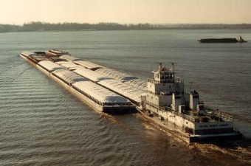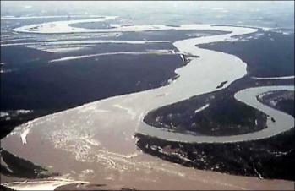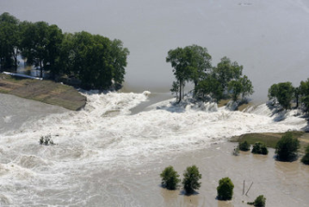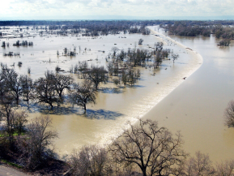

- - Length - 3,800 km
- - Width - Flood Plain is 200 km wide at its widest point
- - Releases 600 million tonnes of sediment of load each year (into the sea and along its course)
- - Flows through 10 states
- - Carries 13% of all freight traffic in the USA

1. What Economic Opportunities are Offered by The River Mississippi?

- - 11 million tourists each year in the upper reaches of river
- - tourism contributes $1.2 Billion to the economy each year
- - Sports Fishing - $100 milling, Waterfowl hunting - $58 million
- - 29 power plants provide energy to vast array of factories and homes
- - Water from river used for cooling in 80% of Energy Production Facilities
- - Silt deposits formed on huge flood plains made area around the river among the most fertile
- regions of the USA (sugar canes, rice, tobacco, and cotton plantations)
- - River provides main transport routes for exports around the world
- - Today over 100 million of commodities transported down the river every year (including 56%
- of the nation's corn, and 41% of soybean exports)

2. What problems/hazards are Presented by the Mississippi?

- - Despite efforts there has been major floods over the last 50 years
- - Particularly severe flood in 1993 (see below)
- - Many people live along the river's flood plains
- - Many scientists have argued that overflowing in a natural part of the river, and should be left to
- happen (prevention measures should be abandoned)
- - One of the worst areas of flooding is the point when the rivers enters its delta at the Gulf of
- Mexico and spreads through distributaries e.g. Hurricane Katrina storm surge at the mouth of the Mississippi in New Orleans
- - Careful management is needed to stop the build-up of sediments causing even more floods
- - The river’s length of 3,800 km means that it's very difficult to prevent flooding
- - needs constant dredging to allow for ship traffic

“Great flood of 1993”
- Between April and October 1993
- 30,000 square miles flooded
- Affected both the Missouri river (tributary of Mississippi) and Mississippi basins
- Caused by a series of storms with heavy rainfall (less time to absorb into the soil or infiltrate) throughout period, in some places 750% more rainfall than usual with rainfall amounts of (125 to 175 mm) in 24 hours
- Lower than average temperatures (less evaporation)
- By the beginning of June the ground was already saturated meaning that continued rainfall went straight into river systems
- St. Louis, river levels were nearly 20 feet (6 m) above flood stage.
- 700 privately built agricultural levees were overtopped or destroyed along the Missouri River.
- Navigation on the Mississippi and Missouri River had been closed since early July resulting in a loss of $2 million (1993) per day in commerce.
- Approximately 100,000 homes were destroyed as a result of the flooding, 15 million acres (60,000 km²) of farmland inundated
- 32 people died
- Approximately $15–20 billion in damages
- River levels breached levees and floodwalls (levees)

3. What Managements/Solutions Have Been Tried/Planned for The River?

Dams, spillways, artificially strengthened levees, river straightening, flood warning systems, afforestation

- - 6 dams along the Missouri, 1600km chain of 105 reservoirs: these hold back water until river levels have lowered and can manage more water
- - 9 dams have been built along the Tennessee river (also a tributary)
- - Afforestation in the upper Mississippi drainage basin system: planting of trees increases interception and increases lag time
- - The Bonnet Carré floodway (9km long spillway) diverts excess water from the Mississippi, 50km north of New Orleans
- - River straightening e.g. one 530 km stretch of river has been shortened by almost 300 km by cutting through meanders. This increases the gradient and speed with which flood waters can be carried away.
- - Reinforced levees using concrete blocks: success in St Louis in 1993 as river levels almost reached the full height of levee but it just managed to hold them back

The opportunities presented by an area or areas of coastline, the associated hazards and their management – North Norfolk coastline

COASTS CASE STUDY: North Norfolk coast
(Cromer, Overstrand and Happisburgh)
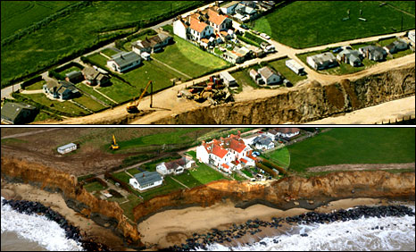

45 miles of coastline, including some of the most rapidly eroding coastline in the world (averages 2m/ year)

Opportunities:
- A UNESCO biosphere reserve until 2014. An area of wetlands and salt marshes and an important habitat for wildfowl and marine animals including seals (Blakeley Point (spit)– an area of outstanding natural beauty). Attracts a large number of tourists for birdwatching
- Tourism includes visiting beaches and attractions such as the pier at Cromer. Over 25% of jobs (over 10,500 jobs) are now in tourist sector bringing in a total of £470 million in 2014.
- The coastline offers opportunities for the harvesting of mussels, cockles, shrimps, crabs, and bait as well as some commercial shore-netting e.g. Cromer Crab
- There are a number of field study centres for educational visits such as Aylmerton Study Centre and Holt Hall
- Some areas are cultivated for sugarbeat and cereals.
- Off-shore wind farm. 88 turbines off the coast of Sheringham.
- Reclaimed land at Blakeley Point is used as pasture and a nature reserve

Causes of erosion:
- Geology: soft, impermeable clay base with soft, permeable gravel above.The impermeable clay traps water percolating through cliffs, causing it to pond and discharge from the cliff face. This leads to an increase in pressure in the cliff, reduced strength of the cliff, which may cause landsliding/ slumping caused by weathering
- As the cliffs are made of soft varied materials with a low resistance this also means that they are very vulnerable to wave erosion and mass movements caused by undercutting, sometimes as much as 10m in one go
- Waves have a long fetch (North Sea).
- Main sea defences (revetments) destroyed in 1990 storm
- Government is enforcing a Do Nothing Policy of managed realignment.
- Narrow beach, unable to absorb much wave energy
- Sea wall to the North at Cromer, Overstrand prevent erosion there and therefore reduce available sediment that could be deposited by LSD at Happisburgh
- Dredging at Yarmouth to the South also deprives Happisburgh of sediment by LSD.
- Granite reef at Sea Palling restricts sediment movement.

Problems/ consequences
- Coastal erosion and cliff recession: Happisburgh & Overstrand. Very severe. Averages 2-5m per year at Happisburgh.
- At Happisburgh: over 26 houses lost to the sea
- Homeowners cannot take out insurance.
- Homes become unsellable / lose value.
- Coastline permanently disappearing.
- Wave action can undercut these cliffs making them prone to failure, especially on low cliffs (10 metres or so), such as at Happisburgh
- problem area - Beach Road runs out to the cliffs and properties here are situated right on the cliff edge
- in 1990 a storm destroyed around 300 metres of wooden revetment to the east of Happisburgh
- in 1996 another length of revetment was lost - rapid cliff erosion followed and six cliff top properties were lost
- at the base of the cliff there is a combination of gabions/flexible concrete blocks/3" steel tubes banded together to lie in a breastwork
- They have also tried groynes and most recently, rock armour.
- Flooding at Blakeley Point. 1953 especially severe (307 killed)
- River Glaven becomes blocked by shingle from advancing spit and floods Cley village.

Action: Happisburgh
- Coastal Concern Action Group set up to lobby North Norfolk District Council.
- North Norfolk District Council gave £200,000 in 2006 for 5,000 tonnes of boulders as rip rap / rock armour..
- Villagers raised a further £50,000 for a further 950 tonnes of boulders.
- This bought the village a 10 year reprieve.

Actions elsewhere:
- The River Glaven has been diverted to prevent recurrence of floods
- Sea walls with promenades have been erected along the coast at Cromer and Overstrand with wooden groynes to keep beach, gabions and some rock armour
- Some revetments at Cromer have helped create a beach
- Beach replenishment by offshore dredging

An area of tropical rainforest – Borneo

Equatorial Forest Case Study: Borneo Climate & Deforestation
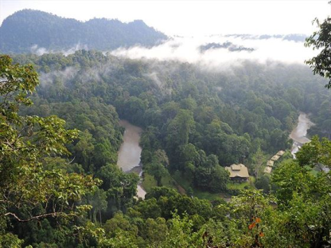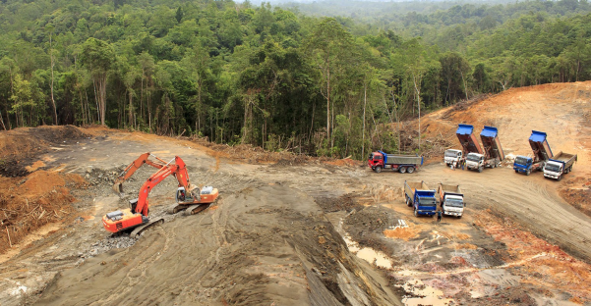

CLIMATE

The Sabah region of Borneo has an equatorial climate and is generally warm and humid all year round.

Temperatures averaging 27°C to 32°C, rarely rise above (32°C). Relative humidity is usually 70-85%.
Diurnal range is low, (3 to 4 degrees) slightly higher in areas of higher altitude.

Rainfall is common throughout the year, and varies from 150 cm to over 450 cm per year. In most parts of Sabah the wettest months occur from October through February and the driest months during from March to September. That said, there is often there is no significant division between the two "seasons."
Latitude: near the Equator so the sun’s rays travel through a small amount of atmosphere therefore allows more insolation (solar radiation) to reach the surface = high temperature
Heavy cloud cover means few rays are reflected back out to space = high humidity and low diurnal rang

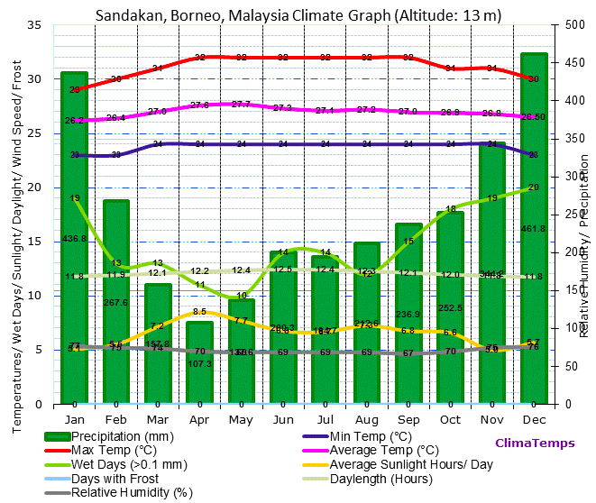

Fauna and Flora

There are about 15,000 species of flowering plants
3,000 species of trees
221 species of terrestrial mammals
420 species of resident birds
440 freshwater fish species
Last remaining habitat of orangutan
Home to the Sumatran rhinoceros

Emergent’s Layer | The Capuche tree is an individual tree with open space around. It reaches 40m high.  Hot and windy. Wind causes evapotranspiration which robs the leaves of moisture.  Leaves are smaller to reduce this. Trees are wind pollinated so they are fluffy.  Little animal life only eagles
Canopy Layer | Dark and humid  Trees have pivoting leaves which follow the sun across the sky. Very large leaves to maximize photosynthesis.  little space so plants grow on tree branches, called epiphytes e.g. Orchid  high biodiversity such as parrots humming birds, insects and monkeys
Under Canopy Layer | little vegetation, bare trunks, no leaves  All energy is focused on reaching the canopy layer to photosynthesise otherwise they die. Lianas grow around the tree.  Snakes and insects use the tree trunks as transport links form the ground upwards
Shrub Layer | Thin in fertile soil due to lack of sun light and leaching  Buttress roots hang 2-3m high above the soil to stabilise them in high winds  Hot and humid which encourages the growth of bacteria and fungi

http://www.wildland.com/destinations/asia/borneo/seasonsclimate.aspx

DEFORESTATION OF TRF IN BORNEO

http://www.borneofutures.org/deforestation.html

Scale:
- The region has lost over half of its forests, and a third of these have disappeared in just the last three decades.
- Current deforestation rate of 1.3 million hectares per year
- deforestation is accelerating and more than 8 million hectares were lost between 2000 and 2010, accounting for 12 percent of its 2000 cover
- Borneo TRFs are said to be 130 million years old, the oldest on the planet.

Causes of deforestation
- TIMBER: over 29,000 km² of TRF in Kalimantan (Indonesian Borneo) were cut down between 1985 and 2001 to supply global timber demand.
- Most timber is logged illegally as protection laws are poorly enforced
- COAL (mining)- Kalimantan holds 53% of Indonesia's recoverable coal reserves
- MINERALS (mining) Borneo is rich in tin, copper, gold, silver, & diamonds
- Palm Oil plantations: palm oil production expanded from 600,000 hectares in 1985 to over 6 million hectares by 2007
- a growth in illegal wildlife trade, as cleared forests provide easy access to more remote areas
- Illegal logging: some 56% of protected lowland tropical rainforests in Kalimantan were cut down between 1985 and 2001 to supply global timber demand
- Additional 10% deforested for agro-industrial crops (about 10 % of the entire Borneo island) mostly rubber trees or acacias for the pulp and paper industry
- mining (for coal or for gold and other minerals),
- infrastructure development (roads, human settlements, etc.)
- Fires can cause extensive damages during El Nino-related drought events

Impacts:
Global Warming and Health | - Burning forest emits a lot of CO₂ into the atmosphere which absorbs radiation and contributes to global warming  - When forests are removed less O₂ is given off  - Smoke from burning forests is also a health hazard, responsible for one in five deaths in South East Asian Island region.  - Deforestation and forest degradation account for up to 20 per cent of global man-made CO2 emissions.
Biodiversity | - Loss of plant species which could have been used for medicines and raw materials in industry  - A 2010 TRAFFIC report estimated that one group in the Malaysian state of Sabah was responsible for taking 22,000 pangolins over 18 months.  - In Japan, the Super Red Arowana can fetch prices ranging between $2,000-$200,000
Death of life and Culture | - Forest clearance in Sarawak for HEP development, oil palm plantations and logging may threaten hunter gatherer way of life for the Penan People who feed on the fruits and nuts and animals in the area  - 56% of protected lowland tropical rainforests in Kalimantan were cut down between 1985 and 2001 to supply global timber demand  - In Kalimantan, the Dayak people are also under threat. They are shifting cultivators who need to be able to move to different areas of the forest once their current plot has had its soil leached. When there is plenty of forest this is sustainable. Now deforestation is forcing them to return to each plot before sufficient years of fallow have passed. As a result crop yield deteriorate.  - Tension between the Dayak and the migrants who were moved to Kalimantan  - Account for over 90 per cent of the world's total oil palm production area Indonesian government has responded by setting a target to increase oil palm production from 20 million tonnes in 2009 to 40 million tonnes in 2020.oil palm production expanded from 600,000 hectares in 1985 to over 6 million hectares by 2007.
Habitats | - Numbers of orang-utan have fallen 50% in the last 50 years due to reduced forest cover. Poaching is easier. Sold as pets.
Soil Fertility | - Cleared land is intensely farmed, loses fertility within 20 years.  - Kalimantan holds 53% of Indonesia's 4,300 million tons of recoverable coal reserves, and Sabah and Sarawak hold 99% of Malaysia's 1,724 billion tons of coal deposits.  Borneo also holds rich metal and mineral resources, including tin, copper, gold, silver, coal, diamonds, and different types of sand and stone.  Together, the forestry and mining sectors are the main contributors to forest loss in Borneo.

Management/ solutions
General | Some areas of Borneo have been designated as national parks, for example, when Kutai National Park was formed in Kalimentan, over 300,000 hectares of forest where made safe from development
Selective Logging | Businesses operating in the area have already taken steps to locate and manage their operations more sustainably.  For example, of the 8.6 million ha allocated in concessions within the Heart of Borneo, 8% of this area is already certified by the Forest Stewardship Council (FSC) or the Roundtable on Sustainable Palm Oil (RSPO), indicating that they are already being sustainably managed.  Individual trees are felled only when they are mature so that the canopy if preserved which protects the ground below  Every tree is selectively logged, up to 30 other trees can be damaged or destroyed getting the logged tree out of the forest
Reducing Debt | Conservation swaps. A country that is owed money by another country cancels part of the debt in exchange for an agreement by the debtor country to pay for conservation activities there.
Promoting responsible Management and Use | The forest and Land Restoration Initiative in Kalimentan has started an aim to restore 900,000 hectares of forest each year by afforestation and reforestation. It involves local government and villagers. Teak is planted as it is valuable and fast growing so can be logged sustainably.  Incentives are given to local farmers to replant trees but they are often not big enough to achieve that aim
Ecotourism | The Tabin Wildlife Resort in the north of Borneo is a wildlife reserve. Rungs are spread across the canopy and ground level for visitors yet does not disturb the wildlife.

An area of hot desert - Namibia – Namib hot desert, South West Africa

Tropical desert case study: Namib desert

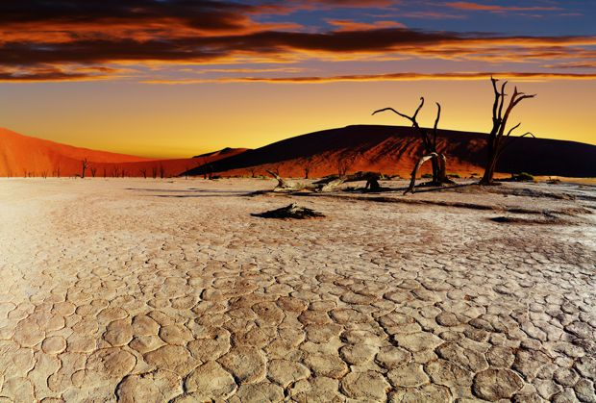

- NAMIB DESERT– Namibia (West of Kalahari)
- Over 1,600 km of coast along SW of Africa, including Angola, Namibia and South Africa, 50 to 160 km wide inland to the Great Escarpment (edge of desert)
- 81,000 square kilometers
- Characterised by some of the largest sand dunes in the world
- One of the oldest deserts in the world

CLIMATE:
- Max Diurnal Range = 9°C (Jun/Jul) (larger inland)
- Annual Mean Range = 5°C
- Mean Max Temp = 22°C (Dec-March)
- Mean Min Temp= 18°C (August) i.e. some seasonal variation as near Tropic of Capricorn and not on Equator.
- Annual Rainfall – 35mm/yr
- COLD OCEAN CURRENT = Benguela Current: a) makes desert cooler than Sahara desert b) creates fog
- Region experiences very little rain but air is often near saturation point = fog
- Fog essential for life. As wind blows east across the cold ocean current it cools the air and water vapour condenses to form fog. The cool air is trapped by the warmer air above it (temperature inversion) resulting in a fog bank forming. Can be up to 20 km wide and forms along the coastal desert.
- Desert is next to the sea = smaller annual range in temp. than Sahara due to the warming effect in winter and cooling effect in summer
- More rain falls inland over the Great Escarpment but water in these streams flowing west into the desert evaporates before it can reach far
- Rain is very rare (only falls on 16 days a year) It can only fall over the Namib Desert when warm, moist air is blown onto the eastern side of the African subcontinent by southeast trade winds. It is highly seasonal.

PLANTS AND ANIMALS:

Animals
Spotted hyena (central and eastern regions), travelling in small groups & feed on gemsbok, mountain zebra
Black-backed jackals often scout beaches for marine carrion (Cape fur seal pups and breeding birds)

Brown hyena
Mountain zebra, chacma baboons, kudu, klipspringer, Cape fox, gerbils, steenbok and a healthy population of leopard are also resident.
Reptiles such as lizards (shovel-snouts, protective eyelids and tubular nostrils allow other lizards to live below the surface) and geckos, the sand snake and the side-winding adder
Scorpions, spiders, fishmoths and beetles that have adapted over centuries to survive in the dune dynamics of the desert.
Insects use a swimming motion to travel through the sand beneath the surface, others dig burrows

Plants
The southern Namib is home to over 600 species of plants, the central Namib 400 species and some 1,000 species in the northern Namib.

Examples:

Pencil bush | Quiver Tree | Welwitischia plant
Grows to 2.5 m  A succulent (stores water in its leaves)  Highly toxic to a number of predators. | Grow to 9m and 2-300 years old  Fibrous core to trunk allows water absorption  Long spiked leaves to reduce surface area and water loss  Leaves produce a white powder which acts as a sunscreen | produces only two leaves over a lifespan of over 1,000 years. These leaves cover and protect soil underneath and help retain moisture. These leaves often split into many segments as a result of wind. 1.4 cm thick leaves mean they are undisturbed by high winds and prevent soil erosion. Plant stomata open in fog to absorb moisture and close in sunshine to reduce heat loss (opposite of what you would expect)

Land use

ECONOMIC ACTIVITY | IMPACT
Diamond mining: a big industry historically. diamonds are found in alluvial gravel beds and require huge amounts of sand to be removed to find them and dumped elsewhere | Removing sand damages the roots of the already very fragile vegetation  Dumping sand elsewhere suffocates the habitat
Nomadic herding: donkeys and goats are put out to graze in herds in the eastern regions where rainfall is high enough for some vegetation ground cover. | Overgrazing as lead to land degradation. Soil is devegatted and exposed to wind and water erosion and soil are blown/ washed away
Adventure Tourism: Off-road driving, sand-boarding, go-carting and illegal poaching | Big game animals such as zebras are being wiped out. Desert vegetation is being eroded by vehicles leading to soil erosion
FARMING: commercial and subsistence, pastoral | -Desertification:52% of the land used for agriculture is moderately or severely affected by soil degradation.  -Food shortage due to drought. The rain is neither predictable nor reliable. In 2013, 500,000 people were affected by drought in Namibia

RESPONSES:

- The coastal desert was names a World Heritage Site in 2012: “The Namib Sand Sea”
- Much of the rest of the desert has been declared part of one national park or another to protect the land and prevent diamond mining
- the Namibian Programme to Combat Desertification (Napcod) has been promoting awareness of the risk of desertification among rural commercial and subsistence farmers
- Napcod has also undertaken a major survey of desertification in the country to assess the scale of damage
- Forum for Integrated Resource Management (FIRM) for Namibian farmers to educate on sustainable farming

A transnational corporation and its global links - Nike


CASE STUDY OF A Transnational Corporation (TNC): NIKE

INPUTS: cheap labour (1 million workers in 2013), capital investment ($14.35 billion in 2016), materials e.g. cotton, rubber etc, land, 765 factories, flat land with access to transport routes and labour market, machinery
PROCESSES: sewing, moulding, cutting, storing, transporting, marketing, R&D,
OUTPUTS: sports and leisure clothing, footwear etc. profit (net income of $4.24 billion in 2017) waste

- Established in 1972. First market = USA
- 1980s, opened regional HQ in Japan to access Asian market
- Produces sports and leisure clothing
- HQ is in Beaverton, Oregon (USA) – 5500 people. This is now its main R&D centre
- 2013 Nike had 765 factories in 43 countries, over 1 million workers
- Has grown through its own brand and by absorbing other brands
- Most factories & workers now in SE Asia due to cheap labour, government incentives, cheap local raw materials, big Asian market with free trade and little transport between countries
- Second biggest market is now China (206 factories) due to abundant cheap labour

PROBLEMS:
- Problem: one child policy has reduced labour availability and making it harder and more expensive to recruit workers (Nike salary in China is $500 but in Vietnam it is $250 so Nike is moving to cheaper LEDCs
- Nike has been accused of paying too low wages. In 2010, 20,000 workers in Vietnam went on strike demanding higher pay
- In 2007, Nike decided to relocate from Indonesia which lead to demonstrations as many other industries depended on the factory workers as a market
- Criticised for poor working conditions and for high greenhouse emissions

Solutions:
- Nike set up 1992 Code of Conduct for all factories to improve working conditions and create a fairer rate of pay/ working hours
- More monitoring of employee skills & development from 2001 and set environmental targets
- From 2012 inspections into greenhouse emissions

A farm or agricultural system - Arable Farm - Glebe Farm, Lincolnshire

Food production case study: ROCKELLS FARM, ESSEX
Large scale commercial farming (inputs, processes and outputs)

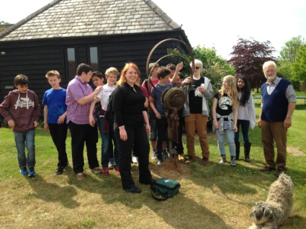
- Rockells Farm, Elmdon, Essex, UK
- Commercial Mixed – 20,000 free range hens, producing 20,000 eggs each day plus grow canary seed
- Turnover is £800,000 per year

Inputs:
- 500 acres of land, gentle relief,
- Chalk/ clay mix (geology), well drained.
- Mild, wet climate. Ave summer temp 17 degrees; 3.5 degrees in Winter. Ave annual rain 650mm.
- Prevailing wind = South westerly. Brings rain
- Use of fertilizers & pesticides. Add nitrates to soil.
- Heavily mechanised e.g. have their own combine harvester, seed drill, tractors. Diesel costs £8000 pa.
- labour: 2 full time, 1-part time employee.
- Diversified their business– holiday cottages, carp fishing lake
- Have 5 solar panels for renewable energy
- Close to M11 and A505 to transport eggs and canary seed
- Machines: 3 tractors, 3 seed drill trailer/ attachments, 3 plough trailers/ attachments, 1 combine harvester/ sprayer
- 6 barns

- 3 grain storage units
- 2 chicken sheds
- chicken wire and fencing
- egg sorting machine
- 20, 000 hens

Processes
- ploughing, seed drilling (use tractor with attached drill or ploughs
- watering, spraying (fertilizer and pesticides), harvesting (combine harvester)
- storage
- transporting canary seed
- feeding hens
- collecting and sorting eggs
- slaughter hens after 1 year
- cleaning out chicken sheds
- adding nitrates to soil

Outputs
- £800,000 turnover
- 20,000 eggs
- 5 tons of canary seed
- waste - chicken excrement

A country or region suffering from food shortages - Madagascar
- Located in southern Africa

Causes of food shortages
- Locust plague which started in 2012 and continued into 2016. This has affected the livelihoods and food and nutrition security of 13 million people. This had a dramatic impact on agriculture production – rice production declined by 21%, resulting in a national rice deficit of 240,000 tonnes in 2013/2014. Maize production in 2013 was also below the national requirement and an estimated 28,000 tonnes of maize had to be imported to provide enough food.
- Madagascar is also prone to frequent natural disasters – since 2009, droughs and cyclones have significantly reduced food production
- Political instability has also affected food production
- Drought - Southern Madagascar’s food crisis of 2020-21, which has pushed more than 1.14 million people into food insecurity, was triggered by low rainfall over a 24-month period. The study finds that the rainy seasons of 2019-20 and 2020-21 brought just 60% of “normal” rainfall to the region, driving “significant crop failure” and “famine-like” conditions across much of the region.

Solutions
- The World Food Programme (WFP) have helped to assist vulnerable people through:
- The provision of food assistance to the most vulnerable people, with emphasis on the needs of children and pregnant and nursing women.
- The construction of irrigation canals, dams and water catchment systems – this will be done through food for work and cash for work programmes
- Support to farmers to increase production of staple crops such as rice and maize
- The promotion of short-cycle crop varieties such as peppers, beans and pineapples which as adapted well to climatic conditions
- Introduction of more efficient water management

An industrial zone or factory – Silicon Corridor, UK (an industrial zone)
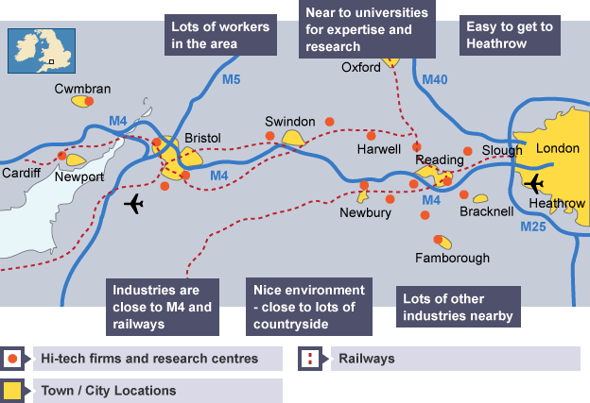

- Silicon Corridor is an industrial zone located to the west of London, along the M4 motorway. Most of these industries are high tech (part of the quaternary sector)
- The M4 corridor stretches from Heathrow airport in the east to Bath and Bristol in the west. The corridor is home to companies such as Hewlett Packard and Sony who are involved in research and development (quaternary industry) and have links with universities who provide well-qualified graduates.
- Few raw materials are used and therefore transport costs are low, making the industries 'footloose'.

Reasons for location:
- Close to the M4, industries have a fast motorway link between the cities of London, Bristol and Cardiff.
- Heathrow is located next to the M4 (west of London) and is the busiest international airport in the world
- It is the location of several government research establishments
- Industries are close to universities (Bath, Bristol, Reading, Oxford) – which provide highly qualified graduate workers, research facilities and expertise
- Agglomeration economies – benefits of businesses locating close together so they can swap both workers and ideas easily

Advantages
- Land on the edge of cities is often cheaper than in the centre. The out of town surroundings and easy access to workers in the suburbs provides an ideal location for building science and business parks.
- Motorway links and railways also provide access for commuters and for transporting components and products.

Examples of some of the business located along this corridor
- Vodaphone - located in Newbury
- Amazon UK headquarters - located in Cardiff
- High-tech businesses - located in Swansea
- Hewlett Packard - located in Bristol
- O2 plc is in Slough

An area where tourism is important – Kenya, East Africa
- Tourism is Kenya’s second largest source of foreign exchange revenue after agriculture.
Physical attractions
- Hot year round temperatures of 28 degrees
- The India Ocean coastline of Mombasa with white sandy beaches and vast coral reefs.
- 19 National parks and game preserves where tourists can take photo safaris and hope to see the big 5 (elephant, kaffir buffalo, leopard, lion and rhino)
- People can climb mount Kenya and stand on the equator line
Human attractions
- A chance to see the Maasai people who are a group of indigenous (native), semi nomadic people who live in the Kenyan parks. The have a distinctive custom and dress and tourists can watch them perform their traditional dances and purchase jewellery and other souvenirs.
Impacts of tourism
- Damage the fragile Kenyan National Parks
- Erosion of tracks as drivers go off track to get closer to the animals (for extra tips)
- The game reserves are often part of the traditional grazing area of the nomadic tribes – but the park boundaries prevent the tribes from moving freely around causing land to be overgrazed (soil erosion).
- Pollution from hotel and tourist facilities at the coast
- Damage to the fragile coral reef systems
- Leakage of money from tourists by foreign owned travel companies – only 10% of the money made stays within the country
- Tourists can offend the local Swahili people who follow the Islamic religion by not dressing appropriately.
- Tourism provides lots of jobs directly (hotels, bars and cafes) but also indirectly (tax drivers, food producers) and triggers a multiplier effect.
- Tourism brings in US$5.3billion to Kenya’s economy

Management
- Entry to the game reserves requires a large fee – which goes towards helping to manage and protect the parks. It costs $80 per adult per day to visit the Masai Mara game reserve.
Ecotourism Kenya runs a standards scheme where 86 facilities have received 23 Gold, 43 Silver and 20 Bronze standard eco-rating certificates.
Ecotourism can play a large part in helping to ensure that there are many social and economic positives coming from ecotourism.
These include:
- Providing well-paid, stable jobs for the locals - these jobs include a wide range of services for tourists.
- High quality education and staff training - many employees and their families will be supported through their education and will be encouraged to continue to learn through their career development.
- ‘Community Development Projects’ - many of local hotels and safari lodges and camps have set up their own ‘Community Development Projects’ where they will support the local community by helping to build homes and infrastructure, wells and water supplies, telecommunications and electricity. Many are also involved in helping improve the healthcare of local communities and will work closely with doctors and health organisations to improve the health of local people.
- Education - some organisations will also support local schools and make sure that they are provided with all the provisions that will encourage children to go to school.
However, perhaps the largest impact that ecotourism can make is in how it can help to impact the environment. These include:
- Supporting local conservation efforts – the money that tourists pay will help to pay for local guides and rangers who will be tasked with helping to protect the land and the wildlife in a particular area.

Energy supply in a country or area - Iceland

Case Study of Energy Supply in a country: Iceland

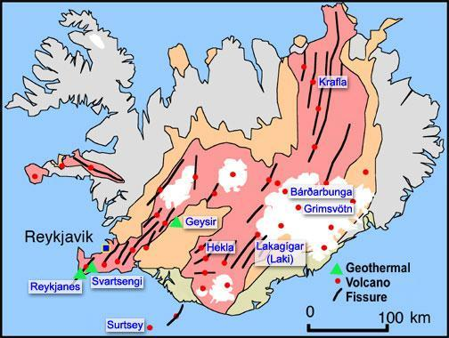

Key Facts
99% of Iceland energy is Renewable

30% Geothermal
60% Hydroelectric
9% Other renewables
Orkuveita Reykjavík, Reykjavík’s hot water utility, is the largest geothermal heating utility in the world
Only 11% of Iceland’s geothermal potential is being utilised with plans to expand and extend the network.

FOCUS: GEOTHERMAL ENERGY:

How geothermal energy is produced & developed by governments
Temperatures in the Earth’s core are very high, >5000°C. Deep underground, rocks & water absorb heat from the magma. Water is pumped down an “injection well”, filters through cracks in the rocks in the hot region & comes up “recovery well” under pressure. It turns into steam upon reaching the surface, which may be used to drive generators to produce electricity, or passed through a heat exchanger to heat water to warm houses.
In 1940s, the National Energy Authority was started by the government in order to increase the knowledge of geothermal resources and the utilization of geothermal power in Iceland. This agency has been very successful and has made it economically viable to use geothermal energy as a source for heating in many different areas throughout the country. The government no longer has to lead research in this field as geothermal power has been so successful & has been taken over by the geothermal industries.
Iceland government also thinks there are more untapped sources of geothermal energy; after tapping them to their full extent, it is estimated that Iceland would get another 50 TWh of energy per year – all renewable.

Location factors considered
- Economy of the area – Blue Lagoon, a tourist bathing resort/ geothermal spa which is one of the most visited attractions in Iceland. Money earned from tourism thus makes the area richer & more economically sustainable than it previously was.
- Needs of people – Nesjavellir Geothermal power station was built to satisfy the hot water demands of people in settlements nearby. All geothermal power stations were built to help
- Near a heat source from the Earth – can be near volcanoes/ reservoir, where injection wells built can first inject cool water into hot basement rock near magma, and the water is heated up and then extracted out again by doublet wells

Benefits
- Low operational & maintenance costs, thus the power plant company can make more profits from providing electricity from geothermal power.
- Renewable source of energy, can replace coal, oil and natural gas which are running out fast. Geothermal energy is environmentally friendly compared to fossil fuel plants, as they only produce a small amount of carbon monoxide.
- Can be a tourist attraction, e.g. Bjarnarflag Geothermal Station has many tourist services nearby. Svartsengi Power Station supports Blue Lagoon, a geothermal hot spring. This could bring in more money for the region, making it more economically sustainable as tourists also go mountain climbing & skiing nearby.

Costs
- Require high investments in machinery. Hellisheidi Power Station decided last October that a number of turbines will be added, along with 90MW – these amounts to $197 million. Construction of a plant & well drilling costs ~ €2-5 million per generated MW of electricity.
- If not done with adequate care enhanced geothermal systems can trigger earthquakes, thus severely affecting land stability & putting nearby areas at risk – potential threat to settlements.
- Before access to potentially huge amounts of energy, the success rate for discovering geothermal resources in new untapped areas is ~20%. In areas near wells already producing, it is 80%.

Water supply in a country or area - California, USA
- Southern California has developed enormously, and it could not have done this without transferring water from the north of the state to the south. The northern state of California has 70% of the state’s water but 80% of the demand for water is from the southern two-thirds of the state. Agriculture uses 80% of the state’s available water – but increasingly demand is coming from large urban areas such as Los Angeles.

- The California State Water Project provides additional water to approximately 25 million people and about 303,500 hectares of irrigated farmland.

- The project is a water storage and delivery system of reservoirs, aqueducts, power stations and pumping plants. It has involved the construction of 21 dams and almost 1,300 km of canals, pipelines, and tunnels.

- Under this project, water is stored (in reservoirs) and distributed (via pipelines) to 29 urban areas and farmland in California. About 70% of the water provided by the project is used for urban areas and industry in southern California and the San Francisco Bay Area, and 30% is used for irrigation in the Central Valley

Negative impacts of this project
- Pumping of water threatens and endangers fish species
- The many reservoirs along the Colorado river have increased evaporation rates which has reduced the amount of water available
- Occasional droughts have reduced the level of water in the Colorado river which has affected the success of the project
- Fish migration has been affected because of low water flows due to water abstraction.
- Agricultural users pay less for water than their urban counterparts which is a source of controversy

An area where economic development is taking place causing the environment to be at risk - Fracking in California, USA
- Fracking is a process for extracting oil and natural gas from the ground by blasting water and chemicals into underground shale rocks.
- Increasingly become a popular method of gaining energy due to improved technologies, costs, energy shortages and the desire for many countries to find their own energy sources.

- The advantages of fracking in California
- There are two major shale-bearing rocks in California: the Monterey shale formation & the Santos formation.
- They are estimated to contain 15.4 billion barrels of oil (80 times California’s annual production from other sources). There are currently over 600 wells.
- These reserves could supply California with energy for the next 21 years.
- Fracking in the US supports over 2 million jobs and contributes US$284 million to the US economy.

- How this activity puts the environment at risk
- Fracking causes chemicals such as benzene to enter aquifers and drinking water which causes serious risk of illness and death to wildlife, the environment and humans
- Fracking involves a huge amount of water and waste water is laced with chemicals so cannot be reused. This poses a threat to the supply of freshwater in a state where droughts are frequent.
- Fracking pollutes the air from oil and gas emissions. It releases methane, a highly potent greenhouse gas that is 56 times more effective at trapping heat than carbon dioxide.
- Wildlife have lost their habitats as forest and vegetation has been cleared to build the fracking wells. Endangered species such as the California condor and the blunt-nosed leopard lizard live in areas where fracking is likely to expand.
- Several minor earthquakes have taken place close to fracking sites – in a state which contains the San Andreas fault

BPP = Bullet Point Plan
You should briefly plan an answer to each question (that is worth 4 marks or more)
For the section c, case study question you should also create a brief BPP. Remember, that for this question you MUST fully develop each point you make. 3 fully developed points (Level 2) is better than listing 5 simple ideas (Level 1). Where possible add place specific information.
BUG the question
Box the command word, Underline the key words and Go back and re read the question.
Make sure you are writing an answer to the question that has been asked.
Using an example you have studied, describe the causes of an Earthquake.
Example =
The key word here is cause. If you write about the impacts you will probably get 0.

7 marker guidance

For each section, there will be a 7 mark question
Success criteria

- BUG the question (Box the command word, Underline the key words, Glance back at the question)
- Have you included and clearly stated a case study example?
- Use clear sentences and link ideas together. Adding connectives are a great way to do this such as: in addition, furthermore, moreover. Also sequence connective: firstly, secondly, finally.
- Use place-specific detail - facts and figures relating to the case study -
- PEEL paragraphs - point, evidence, explain, link

Example questions:

Q: For a named farm or agriculture area you have studied, describe the farming system

Name of farm or agriculture system_______________________

Examples of detail

- An important capital input to Glebe farm came in the form of grants and subsidies from the European Union
- Glebe farm receives the vital input of rainfall all year round and most of the year, temperatures are above the 6'C growing season
- The main outputs of sheep farming in Australia include: 620,000 tonnes of meat and 575,000 tonnes of wool per year

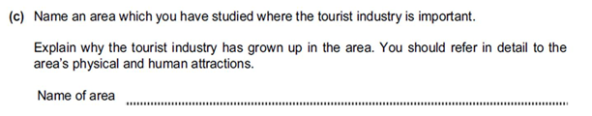
Kenya
Kenya has many physical attractions which over time has encouraged the growth of a flourishing tourist industry. The main physical pull for tourists has to be the 19 game reserves on offer such as Amboseli National Park (the largest) where tourists can observe up close the big 5 such as buffalo in their natural habitat. Safari jeeps, enable tourists to get up close to the animals which provides the perfect photo opportunities. Kenya's year round hot climate (due to its equator location) alongside it's Indian Ocean location and rich coral reef has enabled coastal resorts such as Mombasa to thrive and become more popular by offering water activities such as snorkelling.

Tourists also visit the area due to the human attractions on offer such as a chance to see the local Maasai tribe (an indigenous African group of semi nomadic people) perform their traditional dances. They have a distinct dress and customs which offers a form of cultural tourism. Visitors can also purchase souvenirs crafted by these talented tribes.

