Problems facing soils that affect plant growth include:

**Waterlogging** – resulting in lack of oxygen.

**Erosion** – Either through water, wind or human/animal trampling. The nutrient-rich topsoil becomes damaged.

**Salinisation** – when salt levels build up in soil resulting in toxic soil.

**Structural deterioration** – peds or aggregates form within the soil and alter the soil’s natural drainage.

Places in hot, dry climates often experience food shortages or famine – causing an increase in malnutrition and death rates

Agricultural systems must take into account climate. Hot, dry climates require large i**rrigation** systems to sustain the demand.

Affects human settlements – typically, desert climates (hot or polar) tend to have a low population density

Places with fertile soils tend to have a high population density

Arable land for crops depends on soil type and fertility – fertile soil allows for a strong crop yield, which enables food supply

Zonal soils are soils found in particular regions of the world, e.g. **vertisols** are found in the tropics and subtropics and **podzols** are found in boreal forests

Affects **food security** – places with moderate temperatures and rainfall tend to have high crop yields

Water is essential for human life. Many major settlements are built on riverbanks.

Physical geography and population

Contaminated water, stagnant water and untreated water used for drinking are common factors in disease, e.g. waterborne diseases such as cholera and typhoid can be fatal if not treated properly – this can lead to high death rates in LICs and some NEEs

Typically, countries rich in natural resources (oil, gas, coal and minerals) have experienced rapid development, although this has also led to a widespread wealth gap as well as social and environmental exploitation and injustices

**Water insecurity** is an issue for several countries and can drastically affect development rates

**Topography** affects the development of human settlements, e.g. rocky, mountainous terrain is unsuitable for infrastructural development. This is why a lot of informal settlements are built on this type of topography – as the land is usually not in use or fairly cheap.

Certain climates are perfect breeding grounds for **disease**, e.g. hot, tropical climates are prone to biologically transmitted diseases, such as malaria

**Climate change** is affecting food supply, natural hazard risk/intensity, water security and human development

Water is needed for crop irrigation (whether naturally through precipitation or artificially through irrigation systems). Droughts can lead to famines and impact on human health and development.

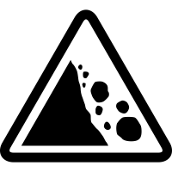

Soils

Water

Geology

Climate

POPULATION ECOLOGY

• **Overpopulation:** when population exceeds the available resources.

• **Underpopulation:** when there is an excess of resources for the population.

• **Optimum population:** when there is an equilibrium between population and resources (the ideal population size).

• **Carrying capacity:** the largest population size that an environment can cope with.

• **Ecological footprint:** the environmental impact of a population.

• **The demographic dividend** is when the number of people in a population’s workforce outnumbers the number of dependents (children and elderly). This is seen as a huge benefit for a country.

• **The age–sex composition** of a population isusually represented in a population pyramid.

• Cultural influences on populations include:

**gender equality** (enabling women to have an education and a career often results in lower fertility and birth rates), **gender preference** (preference for boys in some places may result in female infanticide, skewing the age–sex composition)

**religious controls** (where contraception may be inaccessible, resulting in high fertility rates, and abortions are illegal, resulting in high birth rates and high maternal mortality).

**Malthusian theory:** population will increase geometrically but food supply will continue arithmetically, eventually resulting in famine and fluctuations in total population.

**Boserup theory:** technological advancements will allow food supplies to keep up with geometric population growth.

**Simon theory:** human development allows for a healthier population, while raw materials have become easier and cheaper to access.



**Positive feedback cycles increase the pressure on ecosystems.**

**Negative feedback cycles reduce the pressure on ecosystems.**

GLOBAL POPULATION FUTURES

• The global population is predicted to continue increasing into the   
near future.

• LICs and NEEs are expected to continue to see rapid population increase.

• More HICs are predicted to start seeing a natural decrease and an   
ageing population.

• Environmental factors will change how populations develop:

► Skin cancer and cataracts are likely to increase as a result of ozone depletion.

► Vector-borne diseases and risks associated with natural hazards are likely to increase as a result of climate change.

► Climate change will also affect agriculture and food production.

► Water stress and droughts will result in a higher number of people living in a place of water insecurity.

► Heatwaves and cold spells as a result of climate change are likely to affect health of vulnerable populations.

*The Demographic Transition Model (DTM).*

The DTM shows how birth and death rates tend to decrease over time with development, leading to a population increase. Countries in stage 5 may be experiencing population decline.

Stage: 1 2 3 4 5



Some HICs are experiencing an ageing population (e.g. Japan) as birth rates decline and advanced healthcare reduces mortality. (This is known as a natural decrease.)

Economic migration may cause a demographic shift. Young men are most likely to migrate for work. Qatar has a big migrant workforce so has a large young male demographic.

Migration can also cause a change in population. This includes economic migrants, refugees and asylum seekers. This can create opportunities, such as increased workforce, or threats, such as strains on resources.

As LICs develop, healthcare, sanitation and education improve. This results in lower death rates, causing population increase (natural increase).

**Biologically transmitted disease:** an infectious disease, passed on through insects, animals or people, **e.g. malaria.** It is passed on to humans via mosquitos and is common in hot tropical climates such as that of sub-Saharan Africa (the perfect breeding ground for mosquitos). Lack of access to healthcare and poor sanitation in some areas means malaria is common in poorer areas (particularly in LICs). Malaria can be prevented with nets and mosquito repellent.

**Non-communicable disease:** a disease that is not considered contagious and cannot be passed on between people, **e.g. lung cancer.** This disease is non-contagious but can be fatal if not treated effectively/quickly. Lifestyle, genetics and air quality are linked to rates of lung cancer. HICs/NEEs tend to have higher rates of the disease than LICs due to increased air pollution (largely from industry and vehicle exhausts) as well as trends in lifestyle (such as smoking).

POPULATION AND HEALTH

As agricultural systems develop, food security tends to increase

Extensive farming (e.g. USA)

Commercial farming (e.g. HICs and some NEEs)

Intensive farming (e.g. NEEs)

Subsistence farming (e.g. LICs)

**Types of agriculture**

Health

The **epidemiological transition model** shows how trends in disease change as countries develop:

1. Age of pestilence and famine

2. Age of receding pandemics

3. Age of degenerative and man-made disease

4. Age of delayed degenerative disease

**NGOs:** some are involved in treating diseases, such as providing medicines, or preventing diseases, e.g. through malaria nets, HIV/AIDS awareness and education.

**International agencies (IGOs):** the World Health Organization (WHO), UN (especially UNICEF, UNAIDS, UNWOMEN).

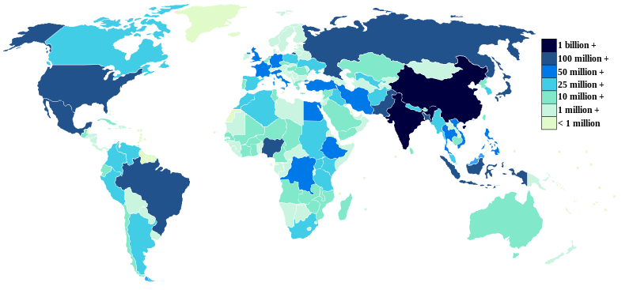

*This map shows global population density. The key refers to the number of people living in each country.*



POPULATION and

THE ENVIRONMENT

SYNOPTIC GEOGRAPHY

**Changing places:** how do populations alter a place?

**Hazards:** why would people choose to live in a place that is at risk from natural hazards?

**Global systems:** how does globalisation affect the distribution of populations?

**Ecosystems:** how does the environment affect where people live?



**Ways to increase food   
security include:**

• Increase food production (growing more crops / grazing more livestock). This can be expensive and there is risk associated as food production largely relies on climate.

• GM crops – to produce disease-resistant crops or food with extra nutrition. This method has caused controversy as altering genes in crops has led to concern about the safety of the practice for both humans   
and the environment.

FOOD SECURITY

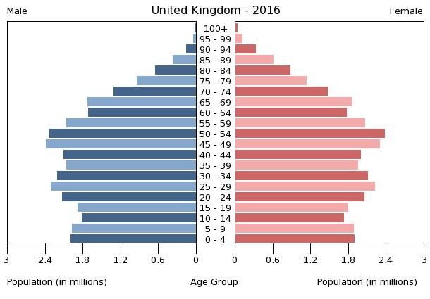

*This pyramid tells us there is a large working-age population and the balance between males and females is relatively even.*