Physically near – e.g. the general region in which you live

Far places may be physically far (distance) or emotionally far (not an experienced or media place)

Near places often evoke a strong sense of place

Emotionally near – e.g. a home town or childhood place of memories

Near

Near places are usually experienced places, but this is not always   
the case

Placelessness

A place someone has physically been to and seen for themselves

When someone feels they do not belong to any one particular place or have any emotional attachment to specific places

Far places can be experienced places too

Belonging – being from a place, living there or having grown up there

Media includes television, film, song, radio, art, books, print media, social media and photographs

Media

Experienced

Sense of place

A place that someone knows well, but may not be a personally experienced place, as it was only seen it in the media

Experiencing somewhere first-hand tends to give people a stronger sense of place than if it were not personally experienced (or a media place)

Far

Attachment – emotional relations to a place, connections to a significant or meaningful event

Commitment – how dedicated or loyal a person is to a place, and willingness to defend it against damage.

Types of place

EXOGENOUS FACTORS

• ‘Outside factors’ that determine a place.

• Connections to the wider region, such as public transport links.

• Connections to wider national, or even international, places, such as train lines, airports and ports.

• Flows of people, capital and goods which are reflected in the demographic or socio-economic make-up of the place.

• e.g. economic shift as a result of   
national recession.

• e.g. demographic shift as a result of an ageing population or migration.

ENDOGENOUS FACTORS

• ‘Inside factors’ that determine a place.

• Physical geography factors, such as geology, topography and climate.

• Human geography factors, such as demographics.

• Population size.

• Local economy sectors and employment rates.

• Land use.

• Infrastructure.

• Local culture and traditions.

• e.g. beaches, famous landmarks, specialist buildings (schools, hospitals, museums).

• e.g. how people have developed a sense of place within this place (home, tourist destination).



Jasmine has friends in Lagos, Nigeria and visits regularly, so she has developed a sense of place.

Jasmine went to Berlin last year, so it is an experienced place but also a far place.

Jasmine’s favourite TV show is *Friends*, so New York is a media place.

The city of Bath is a near place but as Jasmine has never been it is not an experienced place.

Bristol is a near place and an experienced place.

Jasmine lives in Bristol, UK.

SYNOPTIC GEOGRAPHY

**Urban environments:** how do places in cities change with urbanisation?

**Hazards:** how do hazards affect a place? Why are places built near hazards?

**Population:** how do changing demographics affect places?



ChANGING PLACES

TOURISM

• Many people experience places through tourism.

• Places may become popular tourist destinations and naturally the economy becomes tailored around tourist activities (e.g. hotels, restaurants, leisure facilities, excursions/tours).

• Certain places often become synonymous with famous landmarks that become tourist attractions, e.g. the Eiffel Tower in Paris, Big Ben and the London Eye in London, the Sydney Opera House in Sydney, the Statue of Liberty in New York and Christ the Redeemer in Rio de Janeiro.

• Local governments may implement a place branding/marketing scheme to encourage tourism and increase the flow of money into the area.

• Tourists often only see what a place wants them to see – nice hotels, clean beaches and tourist-driven shops. The ‘real’ place may be contrasting to what tourists experience.

• Tourist enclaves or resorts develop in small areas of a place. This often leads to a misrepresentation of place.

• A tourist will have a contrasting sense of place than a local’s one.



Contrasting places

Populations change as a result of migration and development.

These can result in social or economic inequalities.

e.g. increase in ethnic diversity and multiculturalism due to immigration.

Changes from past to present.

e.g. a person’s sense of place may change over time with development, regeneration or a culture/demographic shift.

Qualitative research is one of the best methods to collect data on lived experiences.

Multiculturalism develops as migration continues through a place.

Multiculturalism tends to be a lot higher in cities and urban areas.

e.g. wealth gap as a result of economic shift, leads to extreme poverty for some of the population, but also extreme affluence for a portion.

e.g. as a result of development, industrialisation or deindustrialisation.

Economic shift from primary to secondary and tertiary sectors.

Cultural/social discrimination, e.g. sexism, racism, homophobia.

Media representation of culture.

Regeneration is a common way to increase flows of money for an area in economic decline.

Social inequalities

Culture

Personal lived experiences

Changing demographics

Changing economy

Liverpool is a city in northern England. Historically, the city developed on trade due to its positioning on the coast and had a very busy port that played a major role in the UK’s development.

When deindustrialisation of the UK’s manufacturing industry occurred, parts of Liverpool faced economic decline.

Two of these areas were the Albert Docks and waterfront locations.

The areas were facing economic decline, with empty warehouses and run-down sites.

Since regeneration and redevelopment, the Albert Docks have become home to popular restaurants, bars, cafes and locally made artisan craft shops. The waterfront has since seen a new museum built next to the famous Liver Building, which has seen a growth in visitors since it opened.

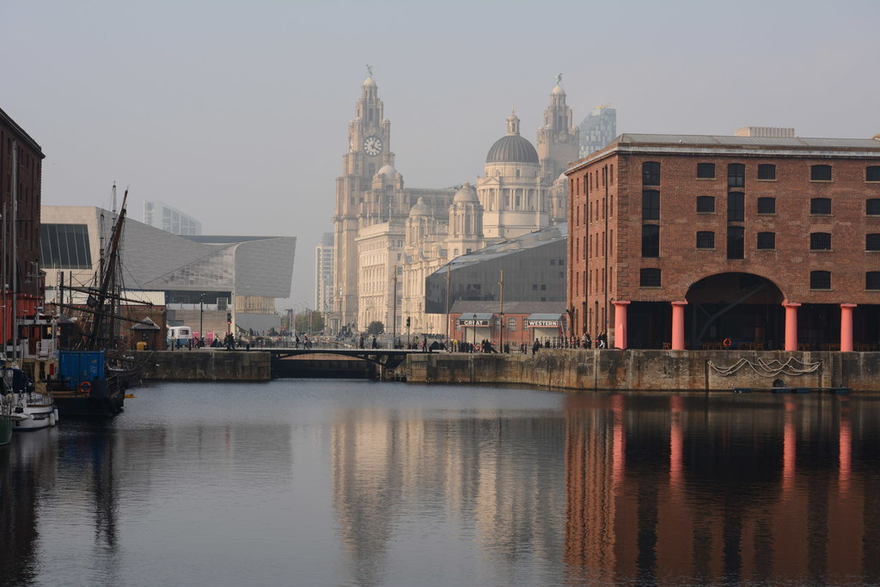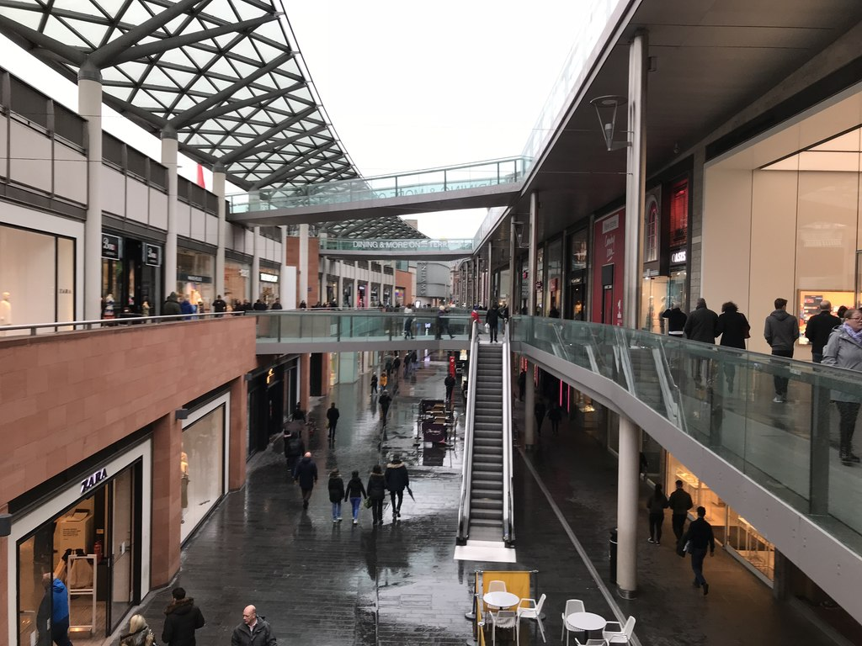

The Albert dock and Waterfront in Liverpool

Liverpool One shopping district.

CASE STUDY – LIVERPOOL REGENERATION

• Media representation of a place can be misleading (e.g. social media representation).

• Places are represented differently in different types of media depending on the genre.

• Many films / TV shows are actually filmed in a different place to the place where they are set, usually because it is cheaper and more accessible for the production companies.

• Media portrayals of historical times (period dramas) often come under scrutiny for historical inaccuracy of places.

• Media can play up to stereotypes of places, which some locals (insiders) feel represents their place in a negative light.



MEDIA AND PLACE