GLOBALISATION

*‘The increasing movement of people, goods, services and information around the world’.*

Global marketing:

TNCs build global brands that are known around the world. This can lead to   
 , e.g. McDonald’s is sold all over the world, the ‘golden arches’ are recognisable in over 100 countries.

:

When brands tailor products to suit local cultures, e.g. McDonald’s tailors its meals to fit in with local cuisines and religious customs.

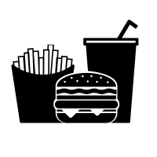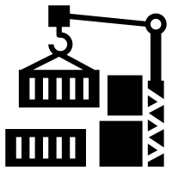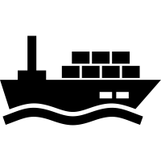

Factors of globalisation:

Remittances, FDI and monetary aid are examples of flows between countries driven by globalisation.

increases the diversification and merging of cultures. This can have positive and negative impacts.

Security: to protect against activity such as drug/human trafficking, goods theft, arms trade and terrorism.

Transport technology has become more efficient, making it and to move people and goods.

technology (e.g. wireless, Internet-based) has significantly increased the flow of information.

**Information**

**Services**

**Products**

**Labour**

**Capital**

# Flows



Global systems

Unequal flows

Injustices

Interdependence

Geopolitical relationships

Conflicts

Poor communities are hit hardest as they cannot afford food. Food riots break out across Country .as a result.

There is a famine in Country .

Country .now has food insecurity.

Country .cannot export food to Country .

Country . experiences a drought and there is no   
crop yield.

Say country A relies on food imports from Country B.

SYNOPTIC GEOGRAPHY



GLOBAL SYSTEMS and

GLOBAL GOVERNANCE

The UN:

• Established in  
 **.**

• Has members and observer states.

• Operates on a global scale and has serval subdivisions that cater to different global needs (e.g.  
 ).

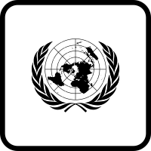



INTERNATIONAL TRADE AND ACCESS TO MARKETS

|  |  |
| --- | --- |
| **Pros of TNCs** | Cons of TNCs |
|  |  |

**Fairtrade** is

**Cocoa beans**

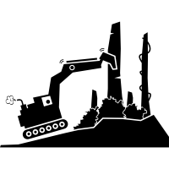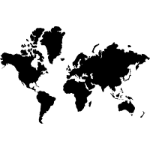

CASE STUDY IN WORLD-TRADED FOOD

GLOBAL GOVERNANCE

# are another example of a difficulty for LICs accessing HIC trade markets.

# Protectionism in HICs can limit LIC/NEE access to foreign trade markets.

# Restricted imports on goods to protect the domestic industry is called p .

Trade restrictions: