Global systems

When two or more countries rely on each other for systems of economics, politics or societies.

Can improve development (e.g. financial investments through FDI).

e.g. while development may help lessen the gap between HICs and LICs, the wealth gap within countries tends to widen (meaning the rich benefit more from FDI, TNCs and technology advancements).

Form when certain groups of people are discriminated against or excluded from certain activities (such as work, affordable housing, educational opportunities).

Often occur as a result of injustices.

Can be unequal.

This can cause inequalities between countries and reduce national resource security.

Some LICs risk becoming dependent on aid / debt relief from IGOs such as the World Bank.

Can create inequalities and injustices (e.g. interdependence between HICs and LICs tends to benefit HICs (core zones) more than LICs (periphery zones).

Can create socio-economic inequalities and can widen the wealth gap.

Examples include income inequality, gender inequality and discrimination based on religion, ethnicity, culture, age, sexuality, and physical and mental abilities.

Environmental injustices occur too as a result of resource exploitation.

This may be on a local, national, or international scale.

May be non-violent (peaceful protest) or violent (armed conflict, riots, civil war or international war).

IGOs have been criticised for favouring HICs (such as the UK, USA, Canada) over the interests of smaller, less geopolitically powerful LICs.

Some trade agreements and trade blocs may benefit HICs more than LICs/NEEs (e.g. NAFTA is often said to benefit the USA more than Mexico).

Unequal flows

Injustices

Interdependence

Geopolitical relationships

Conflicts

GLOBALISATION

*‘The increasing movement of people, goods, services and information around the world’.*

Global marketing:

TNCs build global brands that are known around the world. This can lead to homogenisation, e.g. McDonald’s is sold all over the world, the ‘golden arches’ are recognisable in over 100 countries.

Glocalisation:

When brands tailor products to suit local cultures, e.g. McDonald’s tailors its meals to fit in with local cuisines and religious customs.

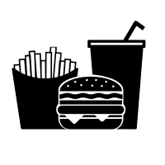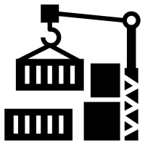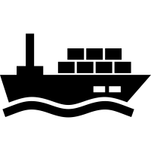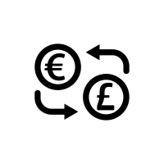

Factors of globalisation:

Remittances, FDI and monetary aid are examples of financial flows between countries driven by globalisation.

Migration increases the diversification and merging of cultures. This can have positive and negative impacts.

Security: to protect against illegal activity such as drug/human trafficking, goods theft, arms trade and terrorism.

Transport technology has become more efficient, making it quicker and cheaper to move people and goods.

Communication technology (e.g. wireless, Internet-based) has significantly increased the flow of information.

**Information**

• Facts, ideas and knowledge

• Increasing due to modern technology

**Services**

• Outsourcing in the ‘race to the bottom’ –cheaper costs for TNCs

**Products**

• TNCs and outsourcing have split goods production all over the world

**Labour**

• People in the workforce

• Driven by economic migration

**Capital**

• The flow of money

• Drives world economy

• Core and periphery zones interact

# Flows



Poor communities are hit hardest as they cannot afford food. Food riots break out across Country A as a result.

There is a famine in Country A.

Country A now has food insecurity.

Country B cannot export food to Country A.

Country B experiences a drought and there is no   
crop yield.

Say country A relies on food imports from Country B.

SYNOPTIC GEOGRAPHY

**Changing places:** how do global systems affect the representation   
of places?

**Ecosystems:** how is the natural world affected by globalisation?

**Population:** can global trade ever be truly fair for all the population?

**Hazards:** how might global governance help in the event of a natural disaster?

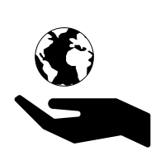

The UN:

• Established in **1945.**

• Has **193** members and 2 observer states.

• Operates on a global scale and has serval subdivisions that cater to different global needs (e.g. **UNEP,** **UNICEF** and **UNDP**).

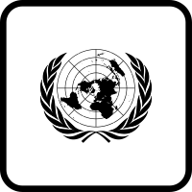

GLOBAL SYSTEMS and

GLOBAL GOVERNANCE



INTERNATIONAL TRADE AND ACCESS TO MARKETS

• Global trade mostly fits into the pattern of HICs importing low-value goods from

• The World Trade Organization (WTO) oversees the majority of trade. The WTO acts as

• LICs and smaller NEEs tend to trade with each other

• The USA, the EU and China all trade with each other and are among each other’s

• NEEs have increased GDP largely through

• Access to trade markets in HICs is difficult

|  |  |
| --- | --- |
| **Pros of TNCs** | Cons of TNCs |
| • TNCs can achieve economies of scale by reducing manufacturing costs.  • Provides people with jobs, which can create a positive multiplier effect. | • Exploitation of workers in LICs/NEEs, such as poor working conditions and low pay.  • Environmental damage, such as air and water pollution. |

**Fairtrade** is a method of ensuring farmers/producers in LICs/NEEs get a good price for their product. It has been criticised for creating unaffordable goods for the mass consumer market and not always ensuring farmers are better off.

• Global governance rallies around IGOs operating geopolitical relations.

• Different scales of governance are affected by global governing bodies (e.g. UN and WTO).

• Global governance interacts with all scales, from local to international.

• For example, global agreements on reducing carbon emissions affect national government policies, which affect regional emission targets and local policy. This is a top-down approach.

• Bottom-up approaches may be achieved through NGOs (grassroots organisations).

• Advocacy NGOs act to raise awareness for certain causes (e.g. Amnesty International).

• Operational NGOs offer physical aid/development or emergency relief (e.g. ShelterBox).

GLOBAL GOVERNANCE

# High tariffs are another example of a difficulty for LICs accessing HIC trade markets.

# Protectionism in HICs can limit LIC/NEE access to foreign trade markets.

# Restricted imports on goods to protect the domestic industry is called protectionism.

Trade restrictions:

• Quotas

• Tariffs

• Embargoes

• Licences

**Cocoa beans**

Cocoa beans are the key ingredient in chocolate.

The raw material is also used in many other food products and in the cosmetic industry.

The beans are grown in largely hot, tropical climates, such as those in South and Central America, the Caribbean, West Africa, and South East Asia.

USA and Europe are among the top cocoa-importing regions.

High demand for cocoa (especially in HICs/NEEs) has led to mass production.

Many cocoa bean farmers are not paid fairly, and concerns over their working conditions have been raised by many pressure groups / NGOs.

Deforestation (for cocoa plantations), land degradation, land scarring and high carbon footprints are some of the many environmental issues raised over the cocoa bean industry.

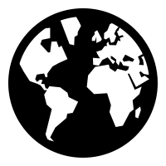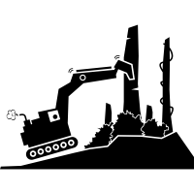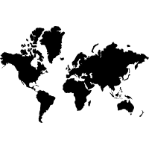

CASE STUDY IN WORLD-TRADED FOOD