EARTHQUAKES

Occur at:

• **constructive**

• **destructive**

• **conservative**

• **collision**

HAZARDS

**Primary**

**Secondary**

Earthquakes release several types of **waves** – primary waves (P waves) are compressions and expansions, secondary waves (S waves) move up and down, and surface waves are love waves (move side to side) and Rayleigh waves (roll like ocean waves).

MAGNITUDE

We measure earthquakes based on energy released and the effects.

• The moment magnitude scale

• The modified Mercalli scale

PREDICTABILITY

Earthquakes are almost impossible to predict. Sometimes there are warning signs –

RESPONSES

Short-term –

Long-term –

PREPARING AND RISK MANAGEMENT

SEISMIC HAZARDS

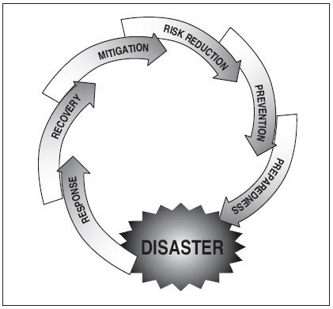

THE HAZARD MANAGEMENT CYCLE

WHAT’S A HAZARD?

Hazard:

Disaster:

There are four types of hazard:

1.

2.

3.

4.

We perceive hazards differently – between countries and within countries – based on reasons (employment, cost–benefit analysis, cost of moving), reasons (fatalism / religious beliefs) and   
 reasons (prior experience, age, gender, education and wealth.

The wealth/development of a country is also a factor in determining the effects of a disaster, e.g. through (reducing the effects of a hazard), (preparing for the event), (rebuilding afterwards) and (forecasting when or where it will occur). Sometimes, the risk can be .

Factors which determine the scale of a disaster include:

The effects of a disaster can be (direct effects, caused as the disaster is playing out), or (resulting from the primary effects and occur afterwards.

We can divide the effects into social (affecting ), economic (affecting and – the economy), environmental (affecting ), and political (affecting ).



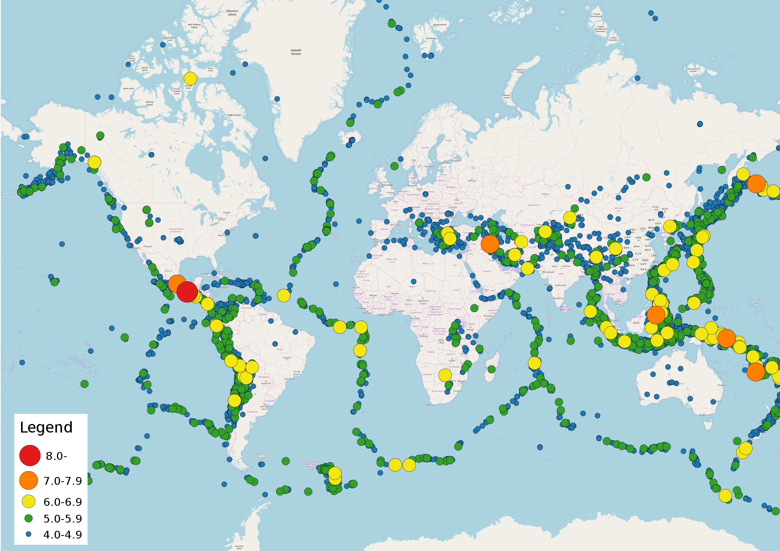

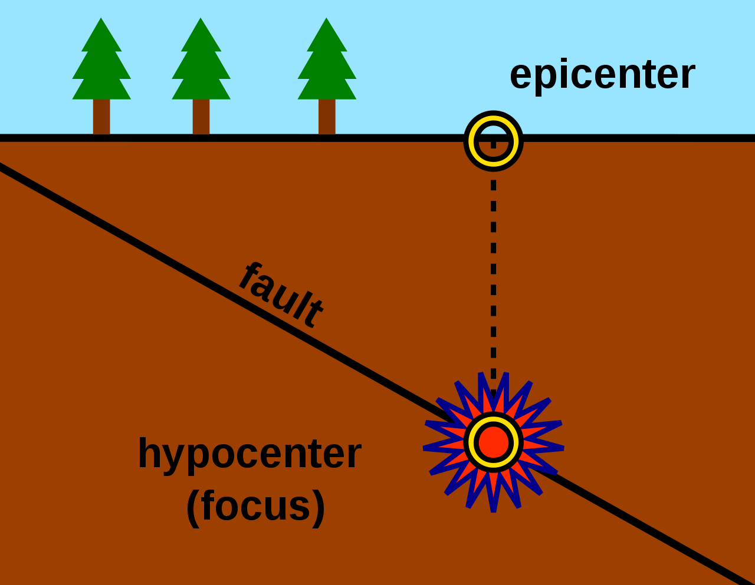

Natural Hazards

PLATE TECTONICS

The Earth is divided up into different layers. Each has a different temperature and thickness. The hottest layer is the inner core at 6,000 °C, and the crust is coolest.

The heat was generated as

The Earth’s crust is divided up into different tectonic plates. The plates are either continental or oceanic (different type of crust, from land or ocean – oceanic are denser and thinner). Alfred Wegener proposed the theory of

Plates move due to several processes, including convection currents (plumes of hotter material slowly rise within the mantle), gravitational sliding (ridge push) (where gravity pushes down at ocean ridges), and slab pull (pulled down by subduction at destructive plate margins).

There are four main types of plate

margin (a.k.a. boundary).

Constructive

Destructive

Conservative

Collision

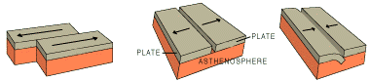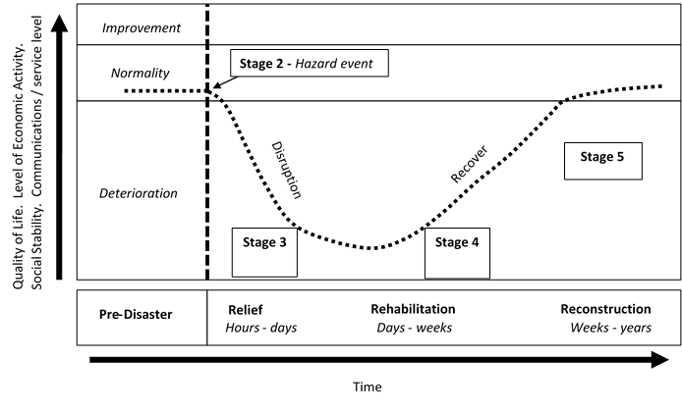

• **The Park model shows**

• **Sometimes, the quality of life**

THE PARK MODEL

**Stage 1** – *Pre-event*

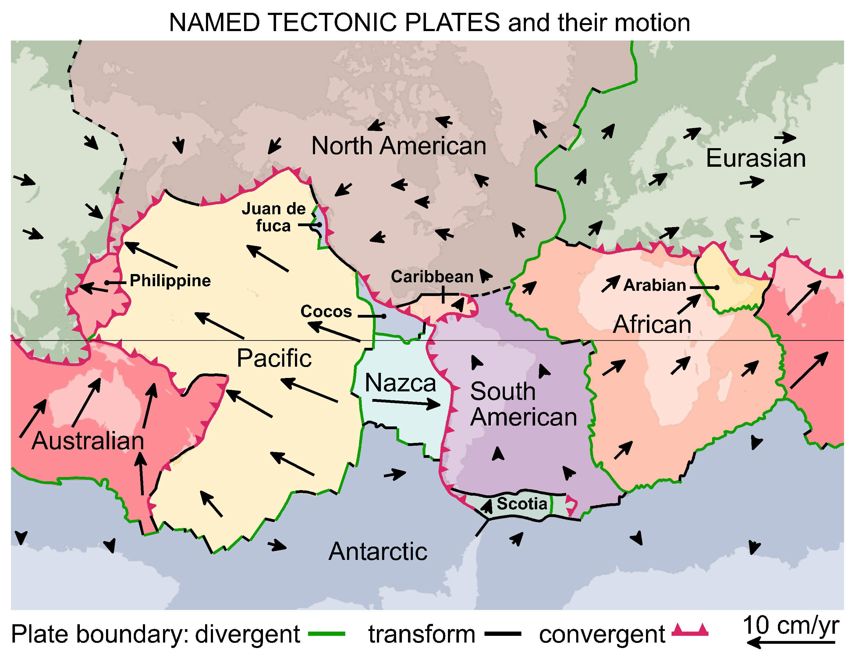

SYNOPTIC GEOGRAPHY

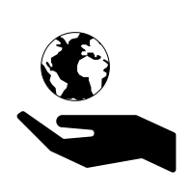

**e.g.**

**Haiti, 7.1 Mw (2010)**

**Japan, 9.0 Mw (2011)**

**Nepal, 7.9 Mw (2015)**

HOW, WHAT, WHY, WHERE?

• 90% of wildfires are caused by humans (both deliberately and accidentally) –

• The rest are caused by

• They burn across many different ecosystems, forests, scrublands and wetlands – many ecosystems are adapted to fire.

• **Surface fires**

• **Crown** fires

• **Ground** fires

• Once alight, fires are spread by .

• The speed of spread is influenced by (dry, low humidity), droughts or periods of dry weather, the of the land (uphill is faster), type of  
 and density – compact vegetation leads to .

• The number and intensity of fires, and longer fire seasons are more likely because of .

RESPONSES TO FIRES

• If the fire is in a remote area and doesn’t affect people, then it may be left to  
 .

• If the fire needs to be contained and extinguished, water and fire can be sprayed on the area from above. Firefighters on the ground can also fight the fire using water, fire and cutting gaps called wide enough that the fire cannot spread across them.

PREPAREDNESS

• Areas at risk are monitored using .

• Ideally, fires are prevented from starting – such as through public or   
controlled burns.

• Planning, shelters and are all useful tools to ensure that fires can be quickly dealt with.

• Planners can also ensure that new towns and buildings are in areas at risk of fires.

**e.g.**

**Mendocino Complex fire, California (2018)**

**Black Saturday, Australia (2009)**

Environmental

Impacts of fires

Economic

Social

FIRES IN NATURE

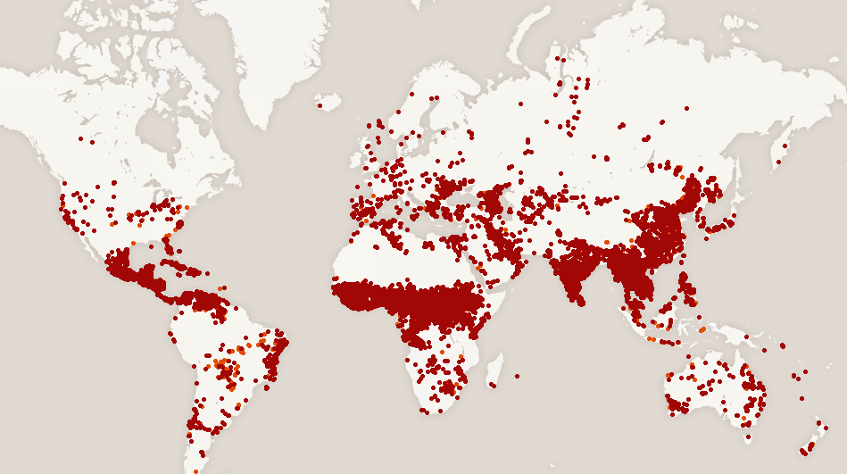

**Chaparral scrubland**

**Maquis shrubland**

**Tropical rainforest**

**Forest, woodland and scrub**

**Savanna grassland**

Nearly all volcanoes (80%) occur at  
 . The rest occur at  
 , and only a handful occur in the middle of plates (see below) – plumes of superheated rock melt through the plate. These are called .

• **Constructive** –

• **Destructive** –

|  |  |
| --- | --- |
| **Shield – constructive margins** | **Composite (Stratovolcanoes)  – destructive margins** |

HAZARDS

Nuées Ardentes (pyroclastic flows) –

Lava flows –

Mudflows (lahars) –

Ash fallout / tephra –

Gases and acid rain –

Climate change –

These hazards can be primary or secondary. Secondary effects include lahars, roof collapses and famine from loss of crops. Of course, the hazards can also be divided into social, economic, environmental and political effects.

MAGNITUDE

We measure volcanic eruptions on the Volcanic Explosivity Index (VEI), based on

PREDICTABILITY

Although it is difficult to predict exactly when a volcano will erupt, we can monitor volcanoes for signs of imminent eruptions – signs that magma is rising, such as

RESPONSES

Responses can be short-term –

Long-term –

Some countries may be able to cope with the eruption themselves, others may be reliant on other countries – especially lower-income countries.

PREPARING AND RISK MANAGEMENT

We can’t stop volcanoes erupting, but we can reduce the effects through...

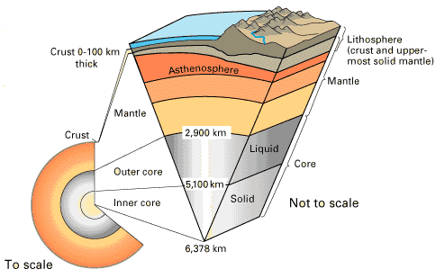

**e.g.**

**Hawaii (Kilauea)**

**Guatemala (Volcán de Fuego)**

**Indonesia (Krakatoa) –all erupted violently in 2018.**

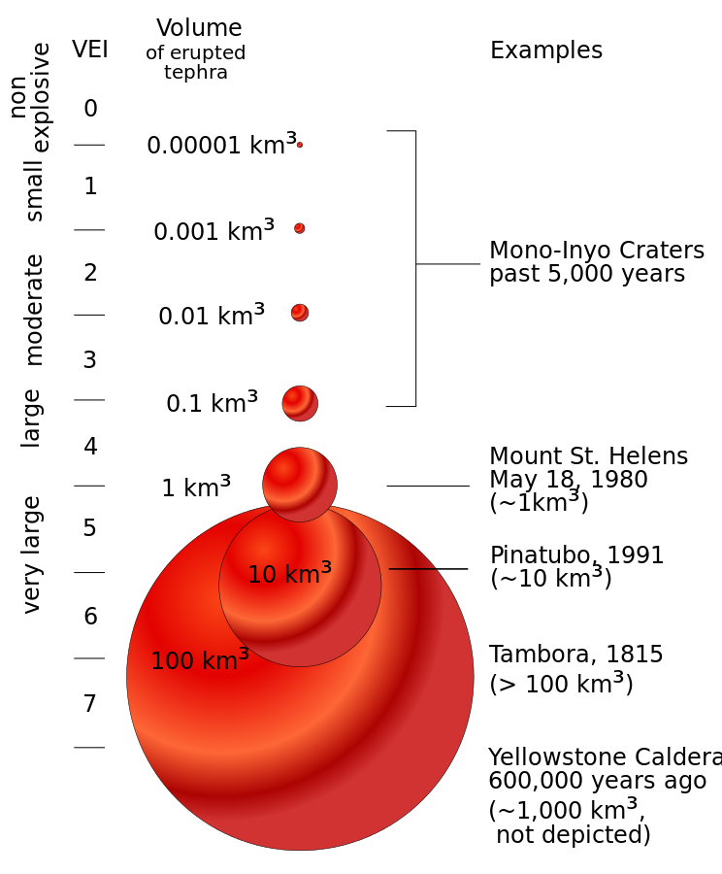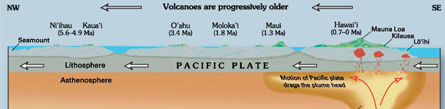

VOLCANIC HAZARDS

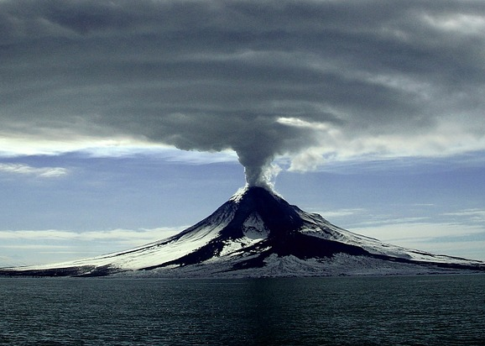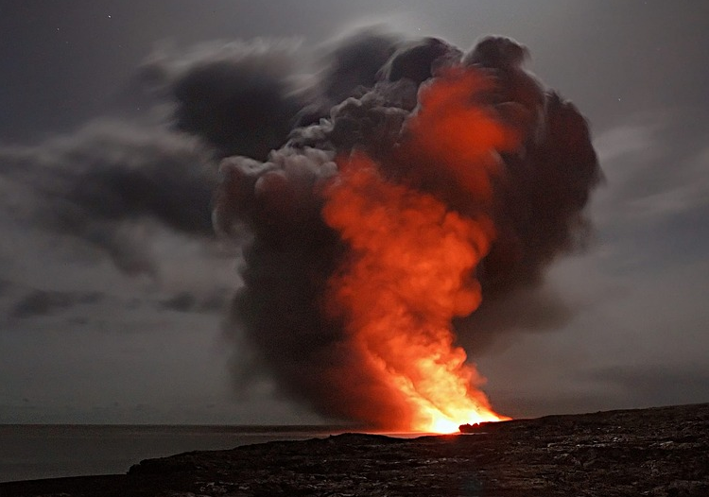

**e.g.**

**Hurricane Michael (2018)**

**Typhoon Yutu (2018)**

**Storm Hudhud (2014)**

**Cyclone Pam (2015)**

STORM STRUCTURE AND FORMATION

• Storms are -pressure weather systems – created as warm moist air . The diagram above shows the main features of a tropical storm – and where air rises and sinks.

• Formation requires deep, warm ocean water (at least °C) to provide latent heat, converging air at the ground, and at least latitude to allow the storms to spin.

• They start out as individual , which combine and begin to spin. They get more powerful as they develop, and are blown along their tracks by  
 winds before veering off towards the . They last between one and two , later dissipating. They lose energy quickly after because their energy source of warm ocean water is lost.

• In each basin, the storms are called different names, such as hurricanes,   
 and cyclones, and each has a different way of classifying storms. One classification system for hurricanes in the Atlantic basin is the   
 which requires sustained winds of at least 74 mph (category 1) – category 5 is over mph!

THE EFFECTS OF TROPICAL STORMS

Tropical storms cause injury and loss of life – people lose property and homes, experience health issues (some are secondary effects) such as water-borne disease, and financial issues – rebuilding, loss of earnings, etc.

The main issues are:

PREDICTABILITY

RESPONSES

• **Immediate** responses include

• **Long-term** responses include

PREPAREDNESS

•

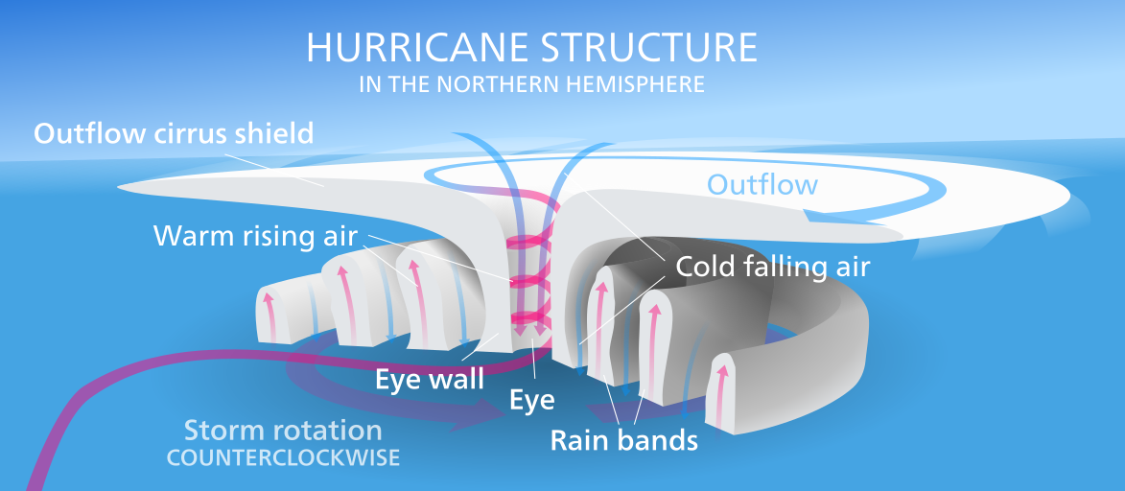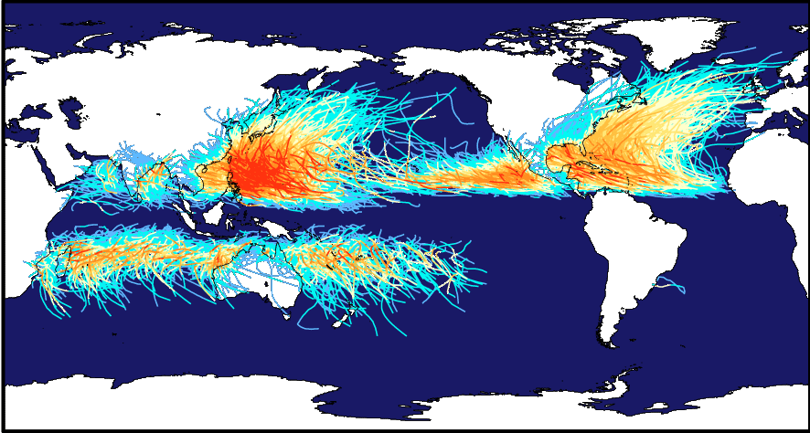

STORM HAZARDS

Storm surges

Winds

Rainfall

Landslides

**Effects of tropical storms**