EARTHQUAKES

Shaking of the ground as built-up pressure is released, plates move – along plate margins and old fault lines.

Occur at:

• **constructive** margins (plates move apart and tension is released)

• **destructive** margins (friction at the Benioff zone means that the plates don’t move fluidly – they stick together and move suddenly, releasing pressure)

• **conservative** margins (pressure released as friction is overcome)

• **collision** margins (as mountains are created and crust is pushed upwards)

HAZARDS

**Primary** effects occur as the ground shakes and the ground cracks open – buildings and infrastructure are destroyed.

**Secondary** effects are caused by the primary effects – liquefaction is where the ground acts as a liquid – buildings collapse and flooding can occur. Avalanches and landslides can also occur. Secondary effects also include impacts resulting from loss of power, services and communications, and fires from broken gas pipes. Tsunami occur when the epicentre is under the sea – the waves travel several kilometres inland and cause massive damage.

Earthquakes release several types of **waves** – primary waves (P waves) are compressions and expansions, secondary waves (S waves) move up and down, and surface waves are love waves (move side to side) and Rayleigh waves (roll like ocean waves).

MAGNITUDE

We measure earthquakes based on energy released and the effects.

• The moment magnitude scale is a logarithmic scale of energy,   
measured by seismometers.

• The modified Mercalli scale is based on the damage caused and how the earthquake was felt.

PREDICTABILITY

Earthquakes are almost impossible to predict. Sometimes there are warning signs – foreshocks. We continually monitor for earthquakes using seismographs and scientific equipment.

RESPONSES

Short-term – planning, emergency evacuation (e.g. tsunami warning) and shelter, search and rescue, supplies of aid – immediately after the earthquake

Long-term – restoring, rebuilding, planning for future events, land-use zoning, etc.

PREPARING AND RISK MANAGEMENT

We can prepare by training and testing plans, by holding drills in schools, by setting up shelters and supplies, and through public education. Buildings can be made more earthquake-resistant (both new and retrofitting old ones).

Local people can adapt their way of life, secure their homes, and prepare for the eventuality.

SEISMIC HAZARDS

• This is a continuous cycle – both before and after a disaster – which includes assessing the risk, and putting measures in place to prepare for and reduce the effects of a hazard.

• It includes the response to a disaster – for example, warnings and the immediate responses, through to long-term recovery.

• New information is provided into the cycle, allowing improvements to be made.

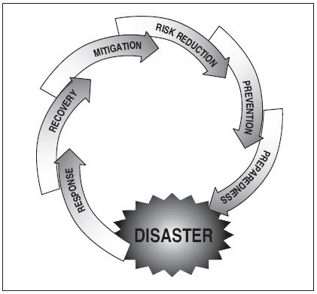

THE HAZARD MANAGEMENT CYCLE

WHAT’S A HAZARD?

Hazard: the potential for damage to health and possessions   
– the risk.

Disaster: If the hazard actually occurs, then this is a disaster. Disasters are beyond our control. Every hazard is different, and they are difficult to compare.

There are four types of hazard: ★geophysical (earthquakes, volcanoes), ★atmospheric (storms), ★hydrological (floods) and ★meteorological (heatwaves).

We perceive hazards differently – between countries and within countries – based on economic reasons (employment, cost–benefit analysis, cost of moving), cultural reasons (fatalism / religious beliefs) and personal reasons (prior experience, age, gender, education and wealth.

The wealth/development of a country is also a factor in determining the effects of a disaster, e.g. through mitigation (reducing the effects of a hazard), planning (preparing for the event), resilience (rebuilding afterwards) and prediction (forecasting when or where it will occur). Sometimes, the risk can be shared.

Factors which determine the scale of a disaster include: the scale (magnitude), the intensity (how quickly the event occurs, where it occurs – remote area or near large city), the geology, the time of day / day of the week, and the frequency with which the events occur.

The effects of a disaster can be primary (direct effects, caused as the disaster is playing out), or secondary (resulting from the primary effects and occur afterwards.

We can divide the effects into social (affecting people), economic (affecting money and businesses – the economy), environmental (affecting the natural world), and political (affecting governments).



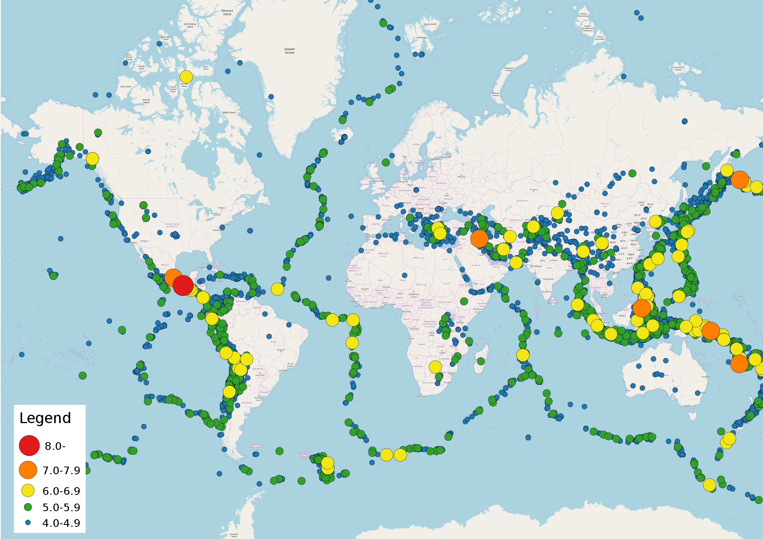

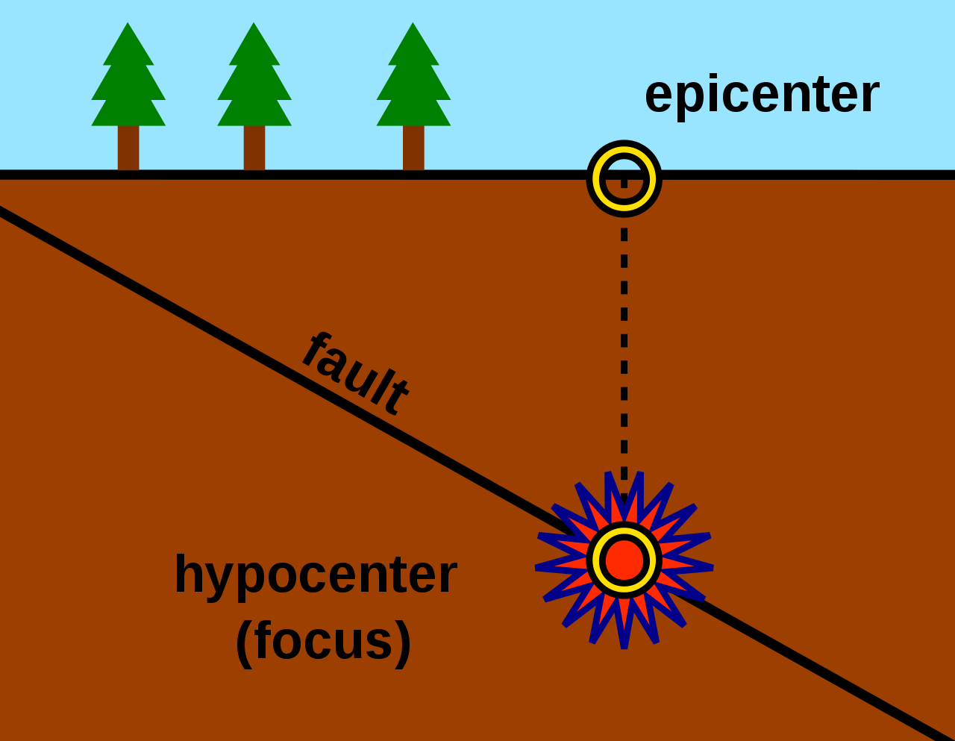

Natural Hazards

PLATE TECTONICS

The Earth is divided up into different layers. Each has a different temperature and thickness. The hottest layer is the inner core at 6,000 °C, and the crust is coolest.

The heat was generated as the Earth was formed (primordial heat), and through radioactive decay of elements.

The Earth’s crust is divided up into different tectonic plates. The plates are either continental or oceanic (different type of crust, from land or ocean – oceanic are denser and thinner). Alfred Wegener proposed the theory of plate tectonics (continental drift), based on the fit of continents, geology and fossil evidence. Later, magnetic striping of the sea floor was discovered.

Plates move due to several processes, including convection currents (plumes of hotter material slowly rise within the mantle), gravitational sliding (ridge push) (where gravity pushes down at ocean ridges), and slab pull (pulled down by subduction at destructive plate margins).

There are four main types of plate

margin (a.k.a. boundary).

Constructive – two plates move apart (usually oceanic) forming new land – and ocean ridges. On land, rift valleys form. Shield volcanoes form.

Destructive – oceanic and continental plates collide and the denser oceanic plate is subducted. Form deep-sea trenches, composite volcanoes and island arcs.

Conservative – two plates move in opposite directions (or in the same direction at different speeds). Form visible fault lines.

Collision boundaries form young fold mountains – two continental plates collide – there is uplift and very little subduction.

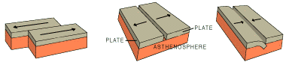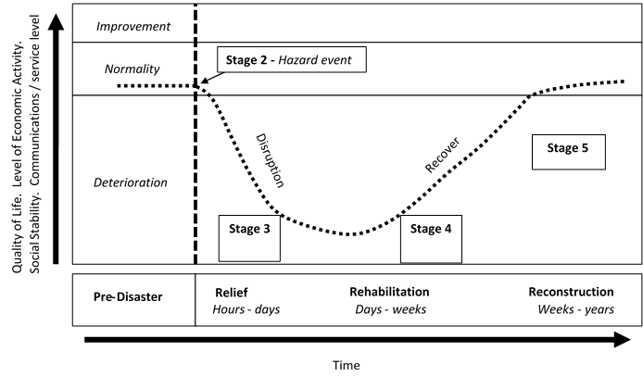

• **The Park model shows** how the quality of life is affected by a disaster and how recovery takes place afterwards.

• The model shows the resilience of a country or area.

• **Sometimes, the quality of life** improves beyond the pre-disaster level. This might occur if the disaster has a very rapid onset. But if the onset is very slow, then recovery might not restore the quality of life back to   
pre-disaster level.

• There are five stages to the model, from preserving life, to the emergency provision of aid, and return to normal, including reconstruction of infrastructure and buildings.

THE PARK MODEL

**Stage 1** – *Pre-event*

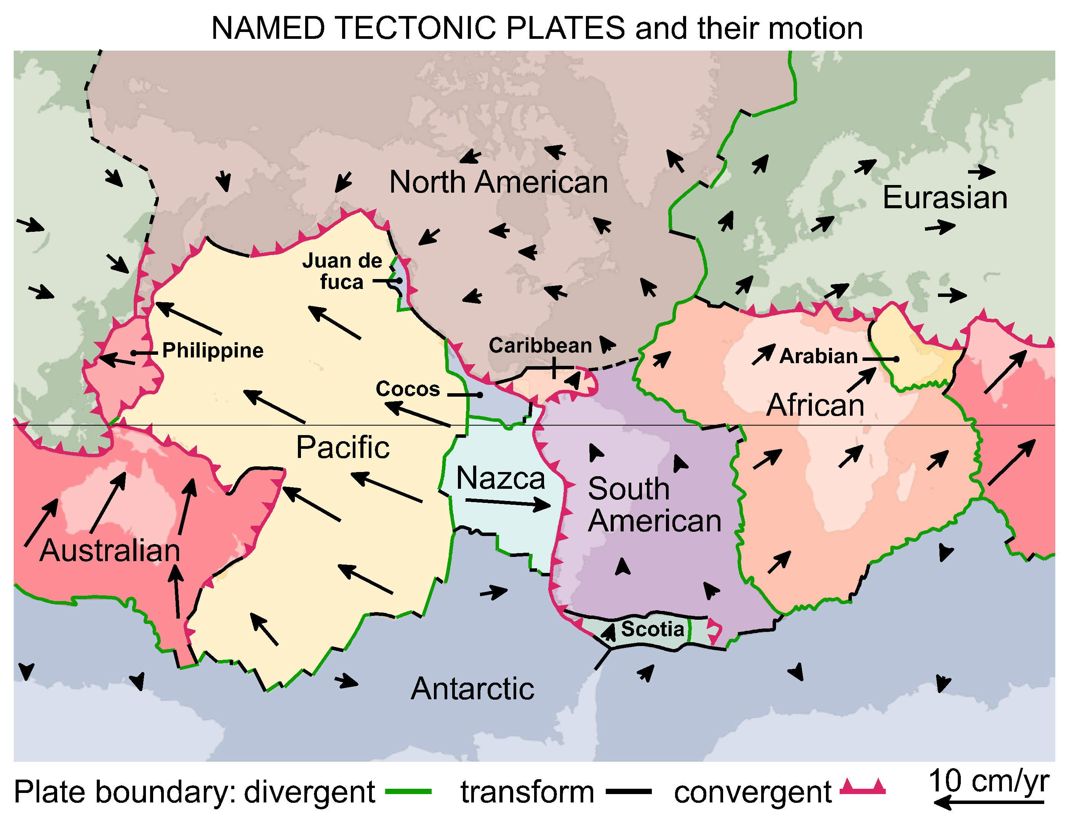

SYNOPTIC GEOGRAPHY

**Water and carbon cycles:** what are feedback cycles? – tropical storms.

**Global systems:** inequalities and vulnerability – why are places vulnerable?

P**opulation and the environment**: are people forced to live in hazardous areas?   
Environmental refugees.

Resources: Do we need geothermal energy?



**e.g.**

**Haiti, 7.1 Mw (2010)**

**Japan, 9.0 Mw (2011)**

**Nepal, 7.9 Mw (2015)**

HOW, WHAT, WHY, WHERE?

• 90% of wildfires are caused by humans (both deliberately – controlled burns, land clearance and arson, and accidentally – out-of-control campfires, dropped matches or cigarettes). The rest are natural, caused by lightning strikes and lava / pyroclastic flows, etc.

• They burn across many different ecosystems, forests, scrublands and wetlands – many ecosystems are adapted to fire.

• **Surface fires** can burn debris on the ground. They burn cool and move rapidly – clearing flammable debris and trees. Plants generally survive surface fires.

• **Crown** fires are hot and destructive – burning in the canopy of trees.

• **Ground** fires burn below the ground and smoulder through peat deposits.

• Once alight, fires are spread by the wind.

• The speed of spread is influenced by weather (dry, low humidity), droughts or periods of dry weather, the slope of the land (uphill is faster), type of fuel and density – compact vegetation leads to hot fires.

• The number and intensity of fires, and longer fire seasons are more likely because of climate change.

RESPONSES TO FIRES

• If the fire is in a remote area and doesn’t affect people, then it may be left to burn itself out.

• If the fire needs to be contained and extinguished, water and fire retardants can be sprayed on the area from above. Firefighters on the ground can also fight the fire using water, fire beaters and cutting gaps called fire breaks wide enough that the fire cannot spread across them.

PREPAREDNESS

• Areas at risk are monitored using satellites.

• Ideally, fires are prevented from starting – such as through public education or controlled burns.

• Planning, shelters and training are all useful tools to ensure that fires can be quickly dealt with.

• Planners can also ensure that new towns and buildings are in areas at lower risk of fires.

**e.g.**

**Mendocino Complex fire, California (2018)**

**Black Saturday, Australia (2009)**

Displacement / temporary accommodation

Expense to fight fires

Can be beneficial to adapted ecosystems

Rebuilding costs

Respiratory problems from smoke

Losses to businesses – e.g. timber production

Loss of property (houses and possessions)

Damage to soil and increased erosion

Death of trees and vegetation, ecosystem destruction

Injury or death if unable to escape

Insurance costs

Environmental

Impacts of fires

Economic

Social

FIRES IN NATURE

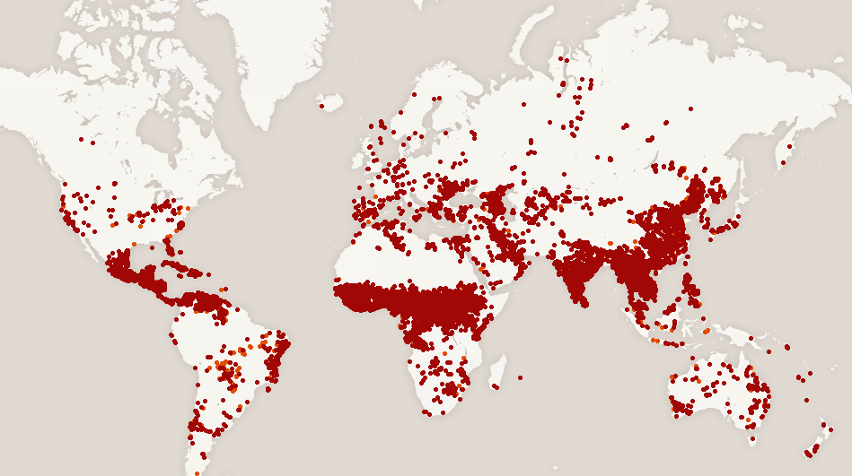

**Chaparral scrubland**

**Maquis shrubland**

**Tropical rainforest**

**Forest, woodland and scrub**

**Savanna grassland**

Nearly all volcanoes (80%) occur at destructive margins. The rest occur at constructive margins, and only a handful occur in the middle of plates (see below) – plumes of superheated rock melt through the plate. These are called hotspots.

• **Constructive** – magma rises to fill the gaps. It’s runny, and from the mantle.

• **Destructive** – local excess of magma from melted crust – sticky.

|  |  |
| --- | --- |
| **Shield – constructive margins**  Low, created by lava flows – hot, basaltic lave, low silica. Gentle, effusive eruptions. | **Composite (Stratovolcanoes)  – destructive margins**  Steep sides – ash and lava flows – cooler andesitic/ rhyolitic lava, high silica content. Explosive eruptions. |

HAZARDS

Nuées Ardentes (pyroclastic flows) – hot gases and ash (up to 1000°C) run down the sides of the volcano, burning everything ★ lava flows – burn the land, start fires and coat the land in new rock ★ mudflows (lahars) volcanic ash flow; bury everything in effectively concrete ★ ash fallout / tephra – ash blocks out the Sun and buries crops and livestock in ash, roads are blocked and roofs collapse ★ gases and acid rain – poisonous gases and CO2 suffocate people and animals, acid rain results from sulphur dioxide ★ climate change – minor sources of CO2 (greenhouse gas) and ash in the stratosphere cause dimming (reflecting sunlight).

These hazards can be primary or secondary. Secondary effects include lahars, roof collapses and famine from loss of crops. Of course, the hazards can also be divided into social, economic, environmental and political effects.

MAGNITUDE

We measure volcanic eruptions on the Volcanic Explosivity Index (VEI), based on the amount of material erupted, the eruption height and the duration.

PREDICTABILITY

Although it is difficult to predict exactly when a volcano will erupt, we can monitor volcanoes for signs of imminent eruptions – signs that magma is rising, such as earth tremors, gas emissions and stream temperature.

RESPONSES

Responses can be short-term – planning, emergency evacuation and shelter, search and rescue, supplies of aid – immediately before, during and after the eruption, or

long-term – restoring, rebuilding, planning for future events, land-use zoning, etc.

Some countries may be able to cope with the eruption themselves, others may be reliant on other countries – especially lower-income countries.

PREPARING AND RISK MANAGEMENT

We can’t stop volcanoes erupting, but we can reduce the effects through infrastructure, risk assessments, hazard maps, plans, monitoring and early warning systems. Local people can adapt. Sometimes settlements can be protected by lahar barriers, and personnel, equipment and shelters can be readied.

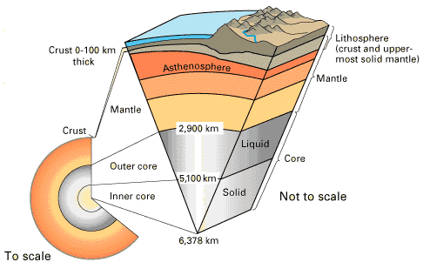

**e.g.**

**Hawaii (Kilauea)**

**Guatemala (Volcán de Fuego)**

**Indonesia (Krakatoa) –all erupted violently in 2018.**

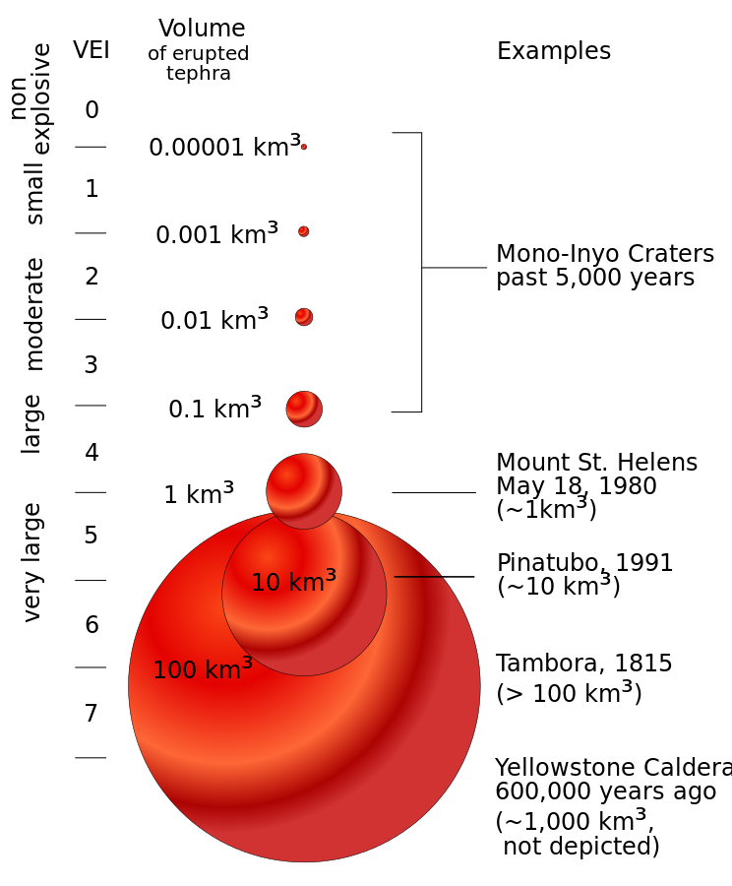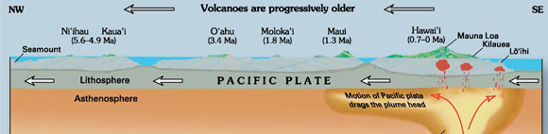

VOLCANIC HAZARDS

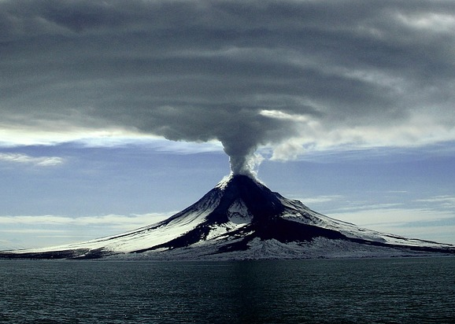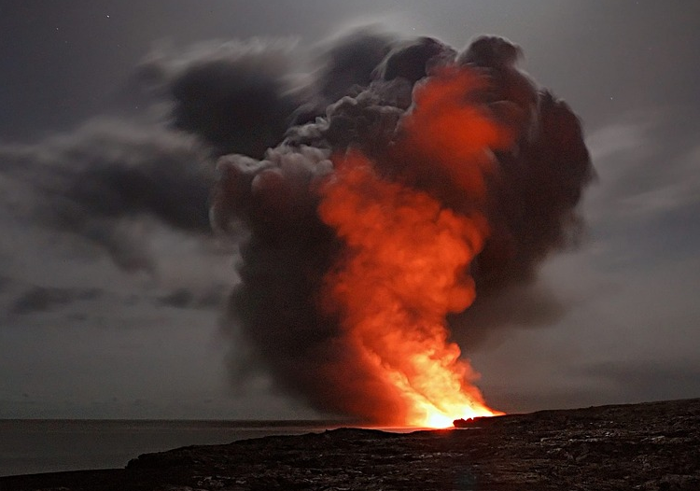

**e.g.**

**Hurricane Michael (2018)**

**Typhoon Yutu (2018)**

**Storm Hudhud (2014)**

**Cyclone Pam (2015)**

STORM STRUCTURE AND FORMATION

• Storms are low-pressure weather systems – created as warm moist air rises. The diagram above shows the main features of a tropical storm – and where air rises and sinks.

• Formation requires deep, warm ocean water (at least 26.5°C) to provide latent heat, converging air at the ground, and at least 5° latitude to allow the storms to spin.

• They start out as individual thunderstorms, which combine and begin to spin. They get more powerful as they develop, and are blown along their tracks by trade winds before veering off towards the poles. They last between one and two weeks, later dissipating. They lose energy quickly after landfall because their energy source of warm ocean water is lost.

• In each basin, the storms are called different names, such as hurricanes, typhoons and cyclones, and each has a different way of classifying storms. One classification system for hurricanes in the Atlantic basin is the Saffir–Simpson hurricane wind scale which requires sustained winds of at least 74 mph (category 1) – category 5 is over 157 mph!

THE EFFECTS OF TROPICAL STORMS

Tropical storms cause injury and loss of life – people lose property and homes, experience health issues (some are secondary effects) such as water-borne disease, and financial issues – rebuilding, loss of earnings, etc.

The main issues are:

PREDICTABILITY

• Each region has its own storm season after the ocean has warmed sufficiently. Once storms develop, we can plot their routes using satellites, and fly aircraft into the storm to take measurements. The tracks can also be estimated (although paths can be erratic). This can give several days’ warning of approaching storms for evacuation orders, shelters to be prepared, and property to be secured.

RESPONSES

• **Immediate** responses include evacuation prior to the storm, emergency shelter and sanitation, and, after the storm, search and rescue. **Long-term** responses include rebuilding and preparing for future storms. Some countries may be reliant on the international community for assistance.

PREPAREDNESS

• Each storm provides new data for the hazard management cycle. Communities and governments can prepare for storms, providing planning, shelters, equipment and staff. Cities can be planned and mapped to minimise risk, and infrastructure, such as storm surge barriers, can be constructed.

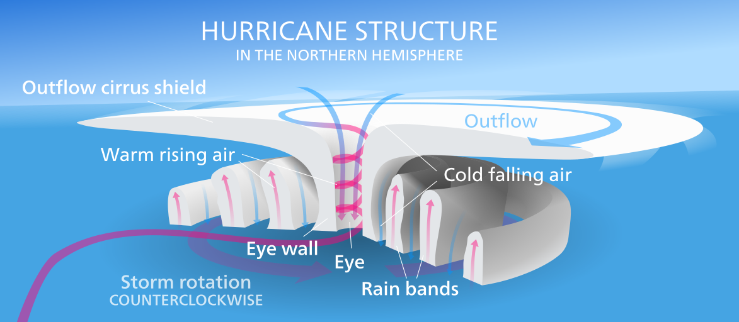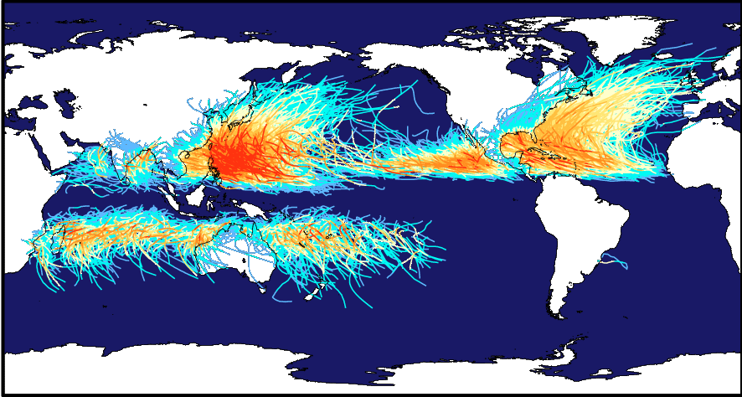

STORM HAZARDS

Destroy homes, make roads impassable and alter the landscape

Damage buildings

Homes and businesses are flooded

Damage soil (saltwater)

Crops are destroyed

Damage trees and crops

Widespread flooding

Down power and phone cables

Damage crops

Flood homes and businesses

Blow roofs off houses, and destroy poorly built structures

Disease – e.g. malaria

Storm surges

Winds

Rainfall

Landslides

**Effects of tropical storms**