COASTAL LANDSCAPE DEVELOPMENT

Headlands:

Wave-cut platforms:

Erosion

# Deposition

**Beaches:**

**Spits:**

**Tombolos:**

**Offshore bar:**

**Barrier beaches and islands:**

**Sand dunes:**

**Stacks**

**Arch**

**Cave**

**Cliff**

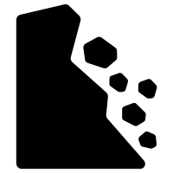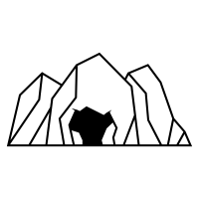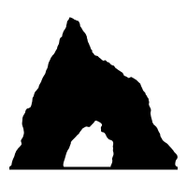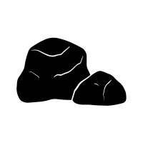

**Tide:**

Systems and processes

**Currents:**

**Wind:**

**Budget:**

**Saltation:**

**Waves:**

**Cells:**

**Run-off**

**Sources:**

**Corrasion/abrasion:**

**Attrition:**

**Wave quarrying:**

**Hydraulic action:**

**Solution/corrosion:**

**Longshore drift:**

**Suspension:**

**Solution:**

**Traction:**

**Soil creep:**

**Rock falls:**

**Mudflows:**

**Mechanical/physical:**

**Landslides:**

**Biological:**

**Rotational slip:**

**Chemical:**

Geomorphological processes

Energy sources

Marine processes

Erosion

Mass movements

Deposition

Weathering

Sediment

Transportation

include energy released from waves, sediment build-up and removal from local system.

include energy from waves, the tide, wind and currents.

When there is an unbalanced flow, there is a system.

When these flows are balanced, they are in **dynamic .**

Coasts are  open systems that have many flows of inputs and outputs.

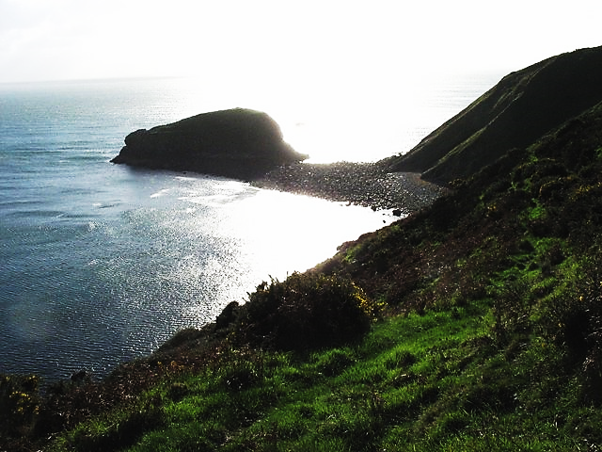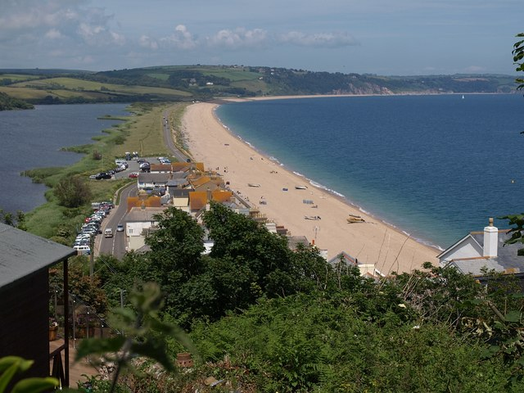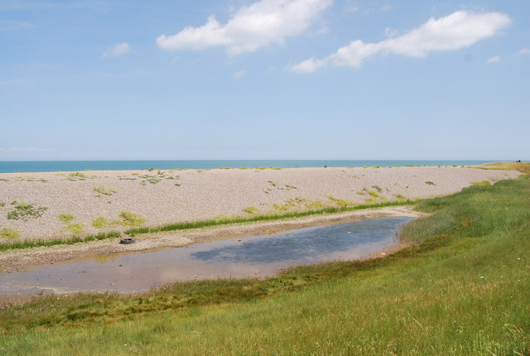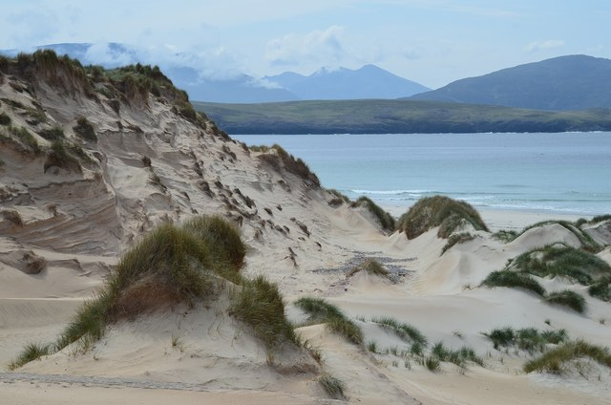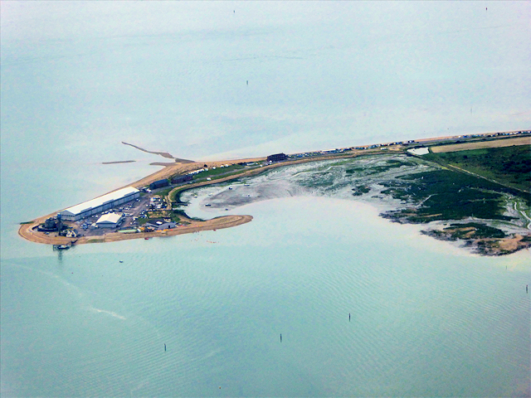

# 1. Tombolo, Porth Cadlan

**3. Bar at Slapton Sands**

# 2. Lagoon and barrier beach

**5. The Calshot Spit**

# 4. Sand dunes, Balnakeil Bay

COASTAL SYSTEMS and LANDSCAPES

SEA-LEVEL CHANGE

**Eustatic change:**

**Isostatic change:**

**Tectonic change:**

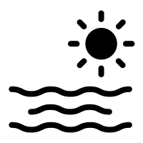

COASTAL MANAGEMENT

Human intervention in the coastline is often necessary to protect the landforms and natural processes of the coast, to conserve biodiversity as well as human settlements, especially those at risk from sea-level rise.

**Hard engineering:**

• **Sea walls** –

• **Rock armour** (riprap) –

• **Gabions** –

• **Cliff fixing** –

• **Groynes** –

• **Revetments** –

• **Offshore reefs** –

• **Barrages** –

**Soft engineering:**

• ‘**Do nothing**’ approach –

• **Beach nourishment** –

• **Dune regeneration** –

• **Land-use management** –

• **Managed retreat** –

**Sustainable management**

**Shoreline management plans** –

**Integrated coastal zone management** –

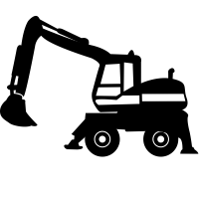

**Mudflats**

**Salt marshes**

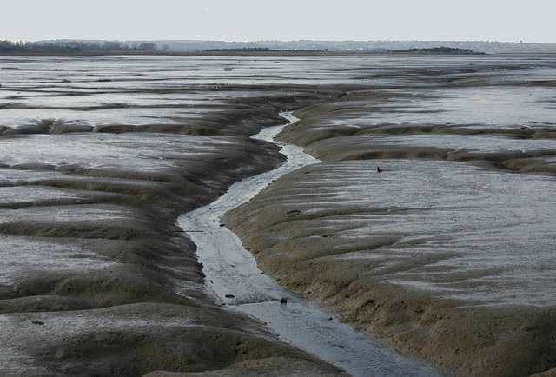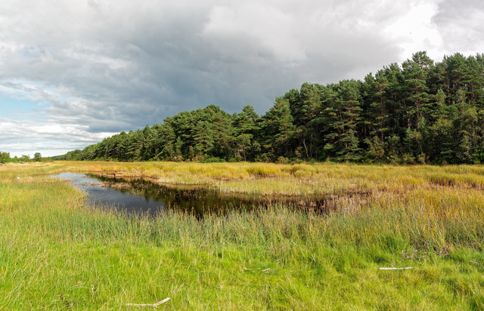

ESTUARINE MUDFLATS AND SALTMARSHES

**EMERGENT FEATURES SUBMERGENT FEATURES**

**Raised beaches:**

**Marine platforms:**

**Rias:**

**Fjords:**

**Dalmatian coasts:**

SYNOPTIC GEOGRAPHY



**CASE STUDY**



Sea level rise is affecting the human population, especially those who live .  
coastal areas.

… and melting   
 that run into the  
sea.

Thermal   
 of oceans…

Enhanced greenhouse effect and   
 .

Anthropogenic   
 gas emissions.

# Climate change

