COASTAL LANDSCAPE DEVELOPMENT

Headlands: softer rock is eroded into a bay, leaving harder, more resistant rock sticking out. The part that sticks out is called the headland.

Wave-cut platforms: bases of cliffs are eroded into a wave-cut notch. The cliff on top collapses and reveals the wave-cut platform.

Erosion

# Deposition

**Beaches:** mostly formed of sand and shingle. Sand particles are smaller than shingle so less water percolates through, meaning a greater backwash and a shallower beach. **Ridges**, **ripples**, **runnels**, **berms** and **cusps** form on beaches as a result of the movement of the water eroding and depositing sediment.

**Spits:** formed when sand and shingle are carried and deposited adjoining the land in a long, thin-ish strip that tends to curve inwards at the end due to wave refraction and wind. **Salt marshes** may form behind the spit. **Simple spits** are straight or recurved but do not have minor spits or recurved ridges, unlike **compound spits.**

**Tombolos:** formed when a spit joins the mainland to an island. The tombolo is the section between the two.

**Offshore bar:** a partly submerged bar, formed of built-up beach sediment away from the mainland and breaker zone.

**Barrier beaches and islands:** formed when beach sediment builds up parallel to the mainland but is not submerged.

**Sand dunes:** formed by onshore wind into large mounds of sand. Dunes may be **embryo dunes**, **fore or yellow dunes**, **grey (fixed) dunes** or **wasting dunes**, with the latter existing longer and further away from the shore.

**Stacks**

The roof of the cave collapses and a tall portion of rock is left as a stack. The stack

erodes into a **stump**.

**Arch**

Arches form when two caves on opposite sides of a cliff (usually a headland) break

through and join.

**Cave**

Cliffs become undercut and eroded. Caves form at the base of cliffs.

**Cliff**

Rock strata are eroded at different paces, depending

on their level of resistance.

Less-resistant, softer rock

is eroded more easily.

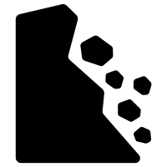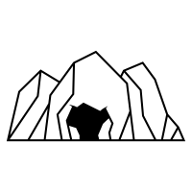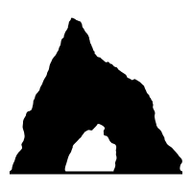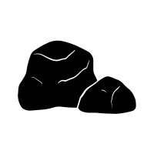

**Tide:** from Sun and Moon’s gravitational force. Tidal surges, such as storms, cause more powerful, higher tides.

Systems and processes

**Currents:** longshore (littoral) drift, rip currents (powerful and hazardous), upwelling (dense cold water movement)

**Wind:** high wind speeds leads to higher wave energy

**Budget:** how much sediment is added and removed from the cell

**Saltation:** small rocks are bounced along seabed

**Waves:** constructive (low height, long length, powerful swash) or destructive (high height, powerful backwash)

**Cells:** areas where movement of sediment is balanced

**Run-off**

**Sources:**

Debris from rivers

Cliff erosion

Offshore sand banks

Organic marine life (shells, skeletons, coral)

Occurs when sediment builds up faster than it is eroded or transported

**Corrasion/abrasion:** rocks and sand wear the cliff face

**Attrition:** smaller rocks are eroded further

**Wave quarrying:** force of air from crashing waves, also called **cavitation**

**Hydraulic action:** force of water

**Solution/corrosion:** carbonic rock are dissolved in acidic water (where fresh meets sea)

**Longshore drift:** sediment is carried by the swash at an angle, the backwash drags it back to the sea – sediment eventually moves across   
the shore

Occurs mostly at low-energy waves **(constructive)**

**Suspension:** sand and small rocks carried by water

**Solution:** dissolved sediment is carriedby the water

**Traction:** large rocks are rolled along seabed

**Soil creep:** soil moves downslope

**Rock falls:** cliff erosion from sea or weathering

**Mudflows:** heavy rain and saturated soil

**Mechanical/physical:** e.g. freeze thaw action

**Landslides:** soft rock and heavy rainfall

**Biological:** erosion from plants and animals

**Rotational slip:** slumping of cliffs

**Chemical:** oxidation, hydration, hydrolysis, carbonation, acid rain

Geomorphological processes

Energy sources

Marine processes

Erosion

Transportation

Mass movements

Deposition

Weathering

Sediment

**Outputs** include energy released from waves, sediment build-up and removal from local system.

**Inputs** include energy from waves, the tide, wind and currents.

When there is an unbalanced flow, there is a **feedback** system.

When these flows are balanced, they are in **dynamic equilibrium.**

Coasts are **natural** open systems that have many flows of inputs and outputs.

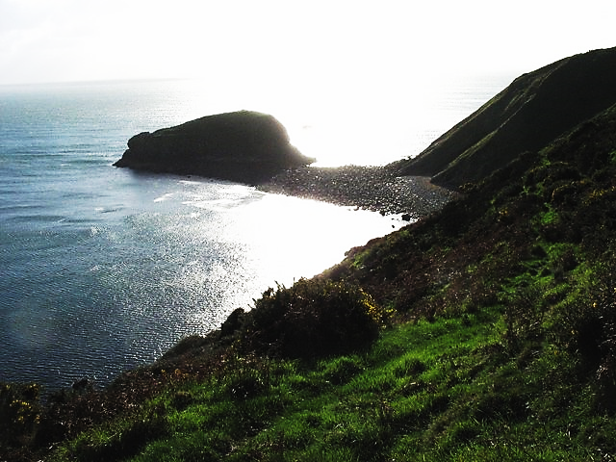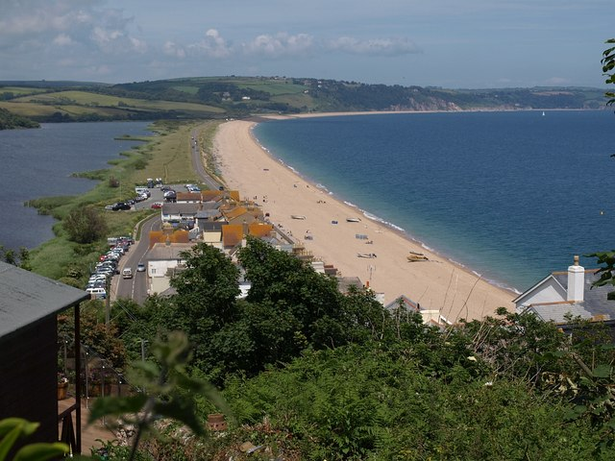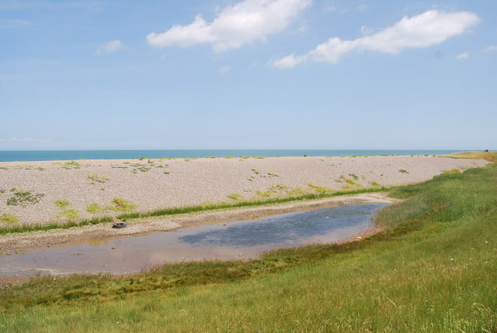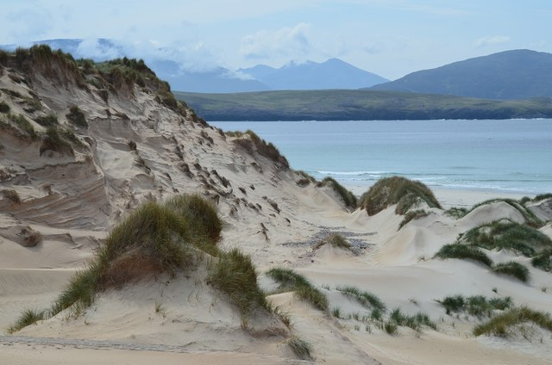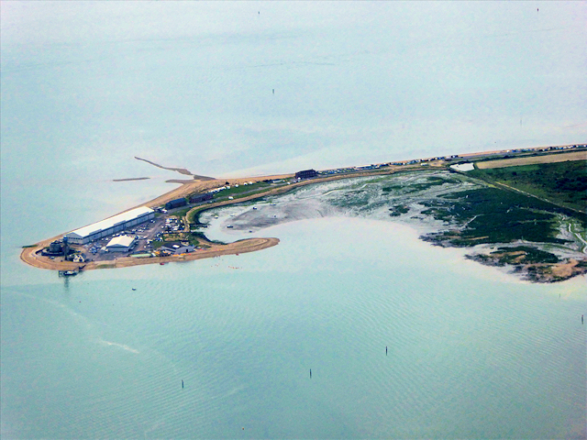

# 1. Tombolo, Porth Cadlan

**3. Bar at Slapton Sands**

# 2. Lagoon and barrier beach

**5. The Calshot Spit**

# 4. Sand dunes, Balnakeil Bay

COASTAL SYSTEMS and LANDSCAPES

SEA-LEVEL CHANGE

**Eustatic change:** a rise or fall in sea level due to the actual **sea** itself. Eustatic rise may occur as a result of decreasing glaciation and ice sheet runoff or thermal expansion, which increases the density of the water (this is the kind of sea-level rise affected by global warming). Eustatic change affects the sea on a global scale.

**Isostatic change:** a rise or fall in sea level due to rise or fall of the **land**. When the land rises, the sea level will decrease, and vice versa. Isostatic change affects the sea on a local scale.

**Tectonic change:** a rise or fall in the sea level due to tectonic activity that causes a   
change in shape of the ocean basin, e.g. subduction zones usually cause a fall in sea level.

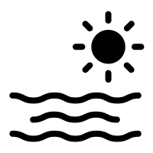

COASTAL MANAGEMENT

Human intervention in the coastline is often necessary to protect the landforms and natural processes of the coast, to conserve biodiversity as well as human settlements, especially those at risk from sea-level rise.

**Hard engineering:** physical change to coastal systems, usually through human-made materials or large human-built structures.

• **Sea walls** – disperse wave energy back onto the next oncoming wave to reduce its power.

• **Rock armour** (riprap) – large, angular boulders are placed to absorb wave energy.

• **Gabions** – small rocks in wire metal cages, which may be joined, to absorb wave energy.

• **Cliff fixing** – iron bars are drilled into the cliff face to help stabilise the cliff.

• **Groynes** – barriers that disperse wave energy and control longshore drift.

• **Revetments** – wood or concrete structures placed on beaches to prevent erosion.

• **Offshore reefs** – to force wave breakage away from the shore to protect the coastline.

• **Barrages** – prevent flooding in estuaries and inland through large dam-like structures.

**Soft engineering:** more natural than hard engineering. Includes ‘**Do nothing**’ approach.

• **Beach nourishment** – replacing sediment that has been lost to longshore drift or erosion.

• **Dune regeneration** – afforestation, selective grazing, restricting human/tourist interaction.

• **Land-use management** – local education on limiting human damage to coasts.

• **Managed retreat** – abandoning old sea defences and managing marshland.

**Sustainable management**

**Shoreline management plans** – to address risks and promote sustainable policies.

**Integrated coastal zone management** – a UN-based approach to coastal policymaking.

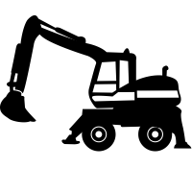

**Mudflats** are shallow plains made from silt and clay. They form in sheltered areas and in estuaries, where freshwater river systems meet the saltwater sea. In high tide, mudflats are submerged under the water.

Mudflats can turn into **salt marshes** as vegetation begins to grow and develop. This usually begins with the growing of **halophytes** – plants that thrive in saline conditions.

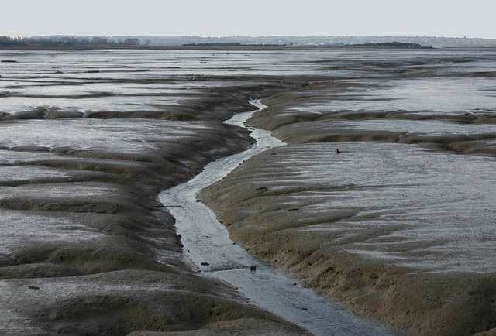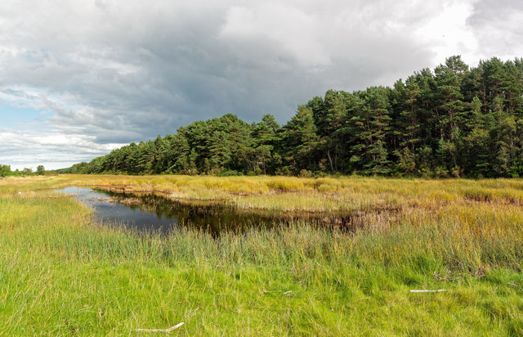

ESTUARINE MUDFLATS AND SALTMARSHES

**EMERGENT FEATURES SUBMERGENT FEATURES**

These occur when isostatic change happens at a faster rate than eustatic change, and landforms are raised **above** the sea level.

**Raised beaches:** beaches on former wave-cut platforms that are higher than the sea level.

**Marine platforms:** formerly submerged land that is raised by land rise or   
sea-level fall.

These occur with eustatic sea level rise or isostatic sea level fall. These features are **below** sea level.

**Rias:** formed when a river valley become **submerged** by sea-level rise. Rias are much shallower than fjords.

**Fjords:** formed when a glacial valley becomes submerged by sea-level rise. Fjords are U-shaped with steep valleys surrounding.

**Dalmatian coasts:** when valleys are parallel to the coast and become submerged by sea-level rise.

**CASE STUDY**

**BLACKPOOL SEA WALL**

Blackpool is a town in north-west England. It is a coastal town, known for being a traditional UK seaside resort. The area is at risk of flooding and so a sea wall was built to reduce the risks and provide protection for the built environment behind the shoreline. However, there was some concern over the stability of the defence after its completion. The original wall was estimated to cost over £27 million.



SYNOPTIC GEOGRAPHY

**Hazards:** how do hazards affect coastal environments?

**Population:** why do people live near coasts?

**Ecosystems:** what ecosystems are found in coastal environments?

**Changing places:** how has human perception of place changed the way we see coasts?

**Water cycle:** how do coasts interact with the natural water cycle?



Sea level rise is affecting the human population, especially those who live in low-lying coastal areas.

… and melting ice caps that run into the sea.

Thermal expansion of oceans…

Enhanced greenhouse effect and global warming.

Anthropogenic greenhouse gas emissions.

# Climate change

