WHERE’S OUR WATER?

Water exists as:

•

•

•

Water can go from liquid to gas ( ), gas to liquid (condensation), ice to gas (or gas to ice) – , freeze to ice and back into liquid water.



Oceans 96.5% of the total water – salty!

Also water in lakes, rivers and wetlands.

water vapour and clouds – the amount is tiny at 0.001% of the total water on Earth!

snow, ice and permafrost – over two thirds of our fresh water

soil water and groundwater – almost a third of our fresh water

WHAT ARE SYSTEMS?

Most systems are driven by the Sun. Systems are either  
 or .

Open systems have of energy and material. Closed systems only transfer in and out.

The water cycle is a closed system overall, but small-scale  
 are open systems.

There are four linked open systems – the atmosphere, the hydrosphere (water), the lithosphere (rock) and the biosphere (living world).

If the inputs and outputs are balanced, the system is in a state of  
 .

Processes called change the equilibrium – positive feedback pushes the system from the previous equilibrium and negative feedback restores the system  
 towards the previous equilibrium.

**Stores (components) and flows (transfers) and processes**

**Inputs**

**Outputs**

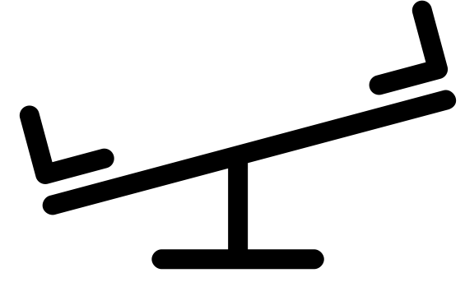

**START HERE!**



• We can calculate the water balance of both catchments and the soil. We use the equation:

• **The soil moisture budget**

• **River flow**

THE WATER BALANCE (BUDGET)

THE FLOOD HYDROGRAPH

A representation of river flow – how the river flow changes after precipitation.

• **Natural factors:**

• **Human factors:**



ARE WE CHANGING THINGS?



The WATER CYCLE

THE WATER CYCLE AT THE HILLSLOPE LEVEL

• **Evaporation:** The Sun provides energy – to  water from the oceans, from the land surface, and from vegetation.

• **Condensation:** The water vapour rises and to form clouds and, therefore, precipitation.

• **Precipitation:** The precipitation falls on the land – some is   
 by trees (some will drip off to the ground or run down the trunks as , and some will evaporate). Some will   
 into the soil and eventually into rock to form the groundwater below (flowing underground). Some will flow through rivers and eventually flow into stores, such as lakes, and eventually the ocean.

• **Transpiration:** Trees and vegetation – water flows through the plants from the soil into the air.

• We can see that many of these are stores and flows!

.

results as the rivers overtop

River levels quickly rise as flow

.

Urban surfaces and drains directly into

.

Water cannot

. into the ground,

. is reduced

. are cut down and the land is sealed off

A city increases in size

WHY DOES IT RAIN?

Condensation:

Orographic:

Frontal:

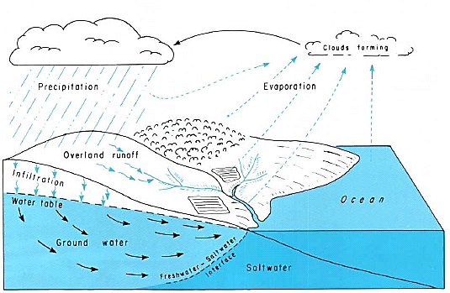

Precipitation

Evaporation

Groundwater

Infiltration

Ocean

Overland run-off

Clouds forming

Antecedent rainfall – the ground is saturated

Downslope ploughing channels water

Drainage of wetlands

Storm events

Farming

Natural

Abstraction of ground and surface water for irrigation

Periods of no standing crops – runoff

Changes to the water cycle

Process of desertification – including overgrazing and use of fuelwood

Altered flow regime of rivers / reduced flooding from reservoirs

Water abstraction

Land-use change

Sealing of the land

Afforestation – to decrease flood risk

Reduced stream flow – abstraction from the river, and reduced base flow from groundwater abstraction

Saline groundwater intrusion (coastal aquifers)

Reduction in the water table

Drought / dry summers

Deforestation – reduced interception and transpiration – large scale affects precipitation and runoff

SYNOPTIC GEOGRAPHY



• **Photosynthesis**

• **Respiration**

• **Decomposition**

• **Combustion**

• **Weathering**

• Humans are releasing huge amounts of CO2 through

• Farming releases CH4 through

• Humans are also increasing the number of wildfires – both deliberately and accidentally

• Deforestation releases

• As population grows and countries develop

PROCESSES WITHIN THE CARBON CYCLE

CHANGES TO THE CARBON CYCLE



THE CARBON BUDGET

The difference between inputs and outputs. Change from natural processes to human changes. Humans are changing the stores and fluxes – decreased stores of – increased atmospheric and dissolved   
 carbon.

Changing the budget can have loops (+ve and -ve).

Land:

More CO2 = more plant growth -> decrease in (-ve feedback)

More CO2 = melting of permafrost -> release of (+ve feedback)

Knock-on effects on weather and droughts, agriculture, and ecosystems.

Oceans:

Thermal expansion and melting ice cause sea level to rise.   
 from dissolved CO2 – coupled with increased temperatures – is disastrous for coral reefs. Reduced albedo from melting ice -> decreases albedo -> more warming ( ve feedback).

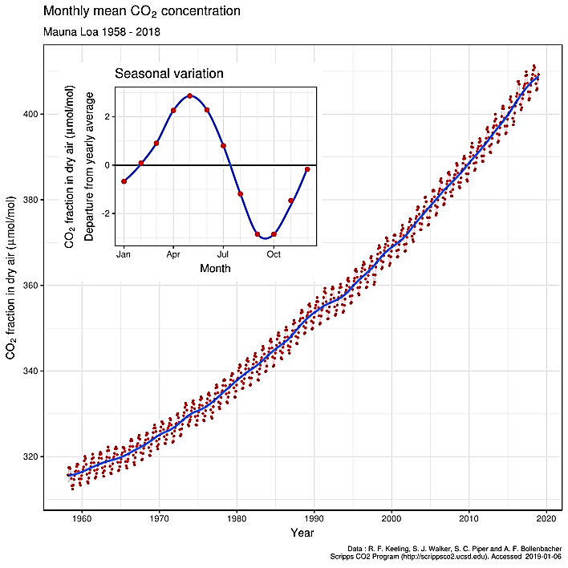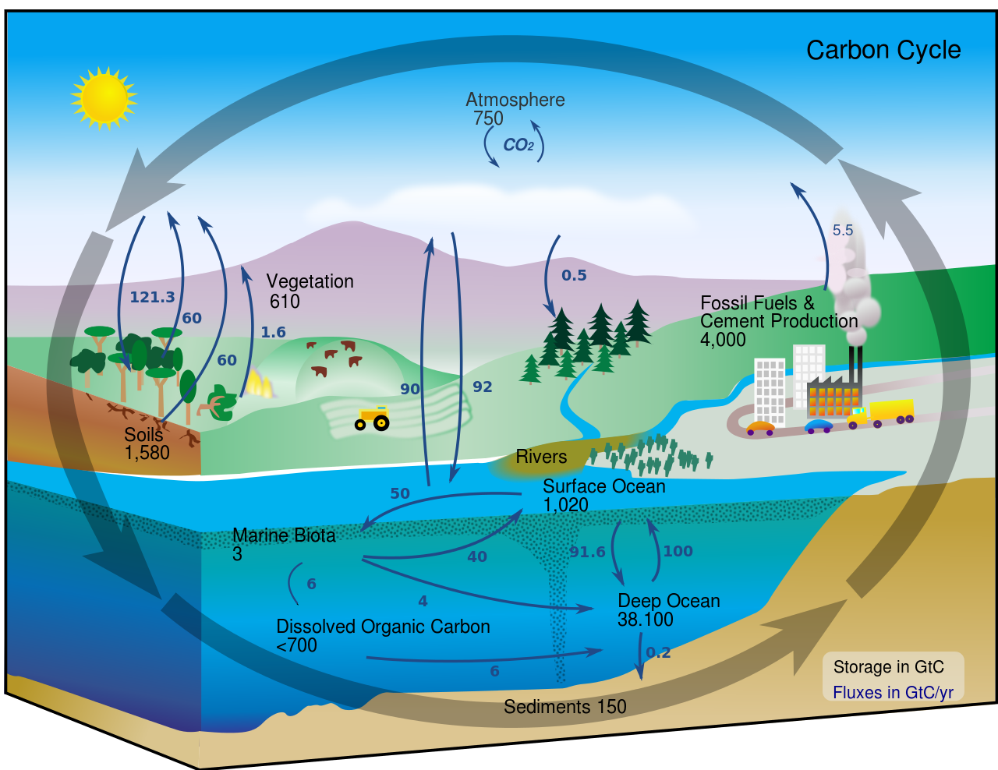

THE FAST AND SLOW CARBON CYCLES

• Carbon can either be organic (from living things), or   
 – from rock.

• The carbon cycle is a   
continuous  .

• There are essentially two carbon cycles – the  carbon cycle (months to years) and the   
 carbon cycle (hundreds of years to millennia).

• The fast carbon cycles transfer CO2 between the oceans and   
 (oceanic inorganic carbon pump), and living things quickly store and release carbon.

• The slow carbon cycle includes the formation of , including burial and compaction of ocean sediments, and the release of CO2 from the mantle to the atmosphere by volcanic activity.

•  are very good at altering the carbon cycle.

SYNOPTIC GEOGRAPHY

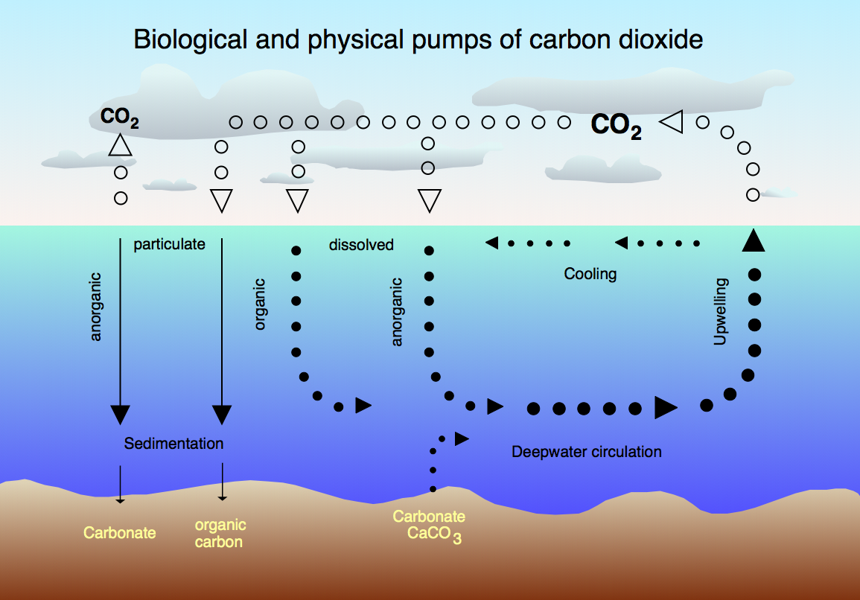

THE ENHANCED GREENHOUSE EFFECT

• Gases such as  are greenhouse gases.



The CARBON CYCLE

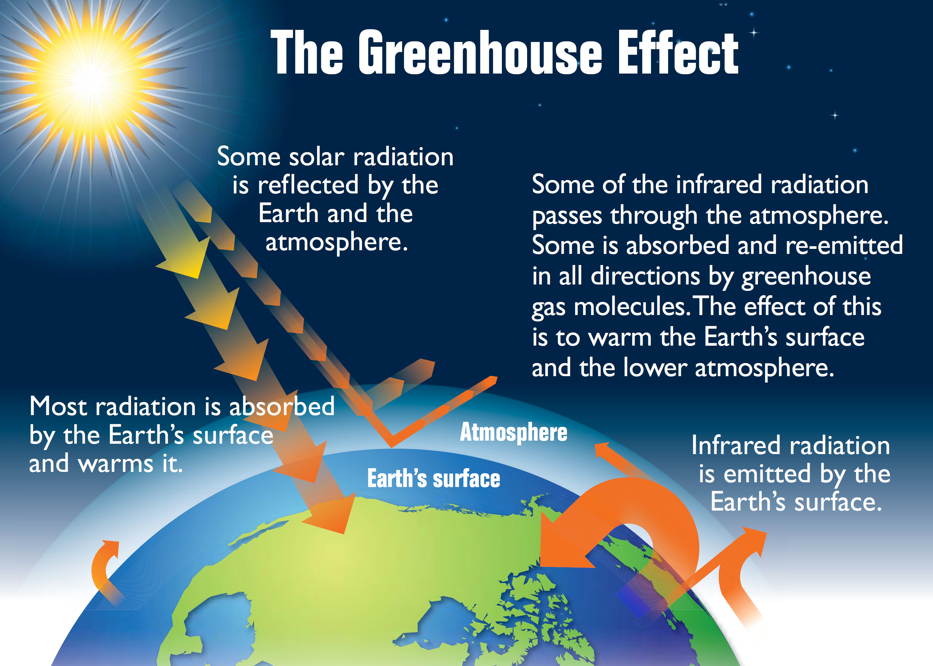

WHAT ARE SYSTEMS?

Most systems are driven by the Sun. Systems are either  
 or .

Open systems have of energy and material. Closed systems only transfer in and out.

The water cycle is a closed system overall, but small-scale  
 are open systems.

There are four linked open systems – the atmosphere, the hydrosphere (water), the lithosphere (rock) and the biosphere (living world).

If the inputs and outputs are balanced, the system is in a state of  
 .

Processes called change the equilibrium – positive feedback pushes the system from the previous equilibrium and negative feedback restores the system  
 towards the previous equilibrium.

**Stores (components) and flows (transfers) and processes**

**Inputs**

**Outputs**



**START HERE!**



REDUCING OUR IMPACT

There are strong links between the water and carbon cycles, and both are vital for life on Earth. We’re causing changes, and we need to limit the effects because of the positive feedback cycles that warming has.

For example, we can:

✓

✓

✓

✓



WHERE’S THE CARBON?

of carbon are measured in gigatonnes. absorb more than they emit, sources of carbon release the carbon faster than they absorb carbon.

The movement between the stores () is measured in gigatonnes per year.

Atmospheric CO2 is measured in ppm – parts per .

**Hydrosphere** –

**Atmosphere** –

**Biosphere** –

**Cryosphere** –

**Lithosphere** –

