WHAT ARE SYSTEMS?

Most systems are driven by the Sun. Systems are either open or closed.

Open systems have inputs and outputs of energy and material. Closed systems only transfer energy in and out.

The water cycle is a closed system overall, but small-scale drainage basins are open systems.

There are four linked open systems – the atmosphere, the hydrosphere (water), the lithosphere (rock) and the biosphere (living world).

If the inputs and outputs are balanced, the system is in a state of   
dynamic equilibrium.

Processes called feedback change the equilibrium – positive feedback pushes the system away from the previous equilibrium and negative feedback restores the system back towards the previous equilibrium.

**Stores (components) and flows (transfers) and processes**

**Inputs**

**Outputs**

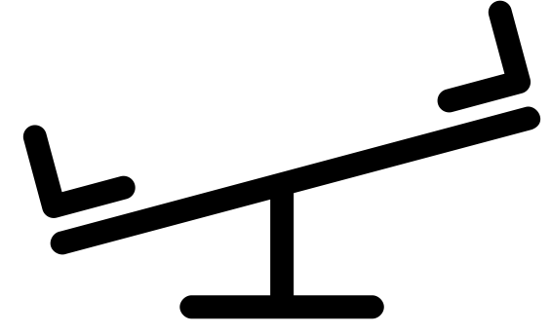

WHERE’S OUR WATER?

Water exists as:

• Liquid

• Solid

• Gas

Water can go from liquid to gas (evaporation), gas to liquid (condensation), ice to gas (or gas to ice) – sublimation, freeze to ice and melt back into liquid water.



**Hydrosphere** – Oceans 96.5% of the total water – salty!

Also water in lakes, rivers and wetlands.

**Atmosphere** – water vapour and clouds – the amount is tiny at 0.001% of the total water on Earth!

**Cryosphere** – snow, ice and permafrost – over two thirds of our fresh water

**Lithosphere** – soil water and groundwater – almost a third of our fresh water

• We can calculate the water balance of both catchments and the soil. We use the equation:

• **The soil moisture budget** changes throughout the year based on changes in precipitation, potential evaporation and the uptake from plants. In the UK, rainfall is highest in the autumn and winter, when soil moisture and groundwater recharges. In the summer, potential evaporation is highest, and plants are using lots of water!

• **River flow** also changes throughout the year – called the regime. When it rains, water travels to the channel via the surface. When it doesn’t rain, rivers flow because of their base flow – from the soil and groundwater. Some rivers dry up entirely in the summer.

THE WATER BALANCE (BUDGET)

**THE FLOOD HYDROGRAPH**

A representation of river flow – how the river flow changes after precipitation.

• **Natural factors:** If the river responds quickly to precipitation – high peak flow and short lag time – we say that the hydrograph is ‘flashy’. The hydrograph may be flashy due to natural factors, based on the shape, size, relief and geology of the drainage basin.

• **Human factors:** humans can also cause a hydrograph to become flashy – through land-use change, urbanisation, farming practices and deforestation.



ARE WE CHANGING THINGS?

Humans are emitting greenhouse gases – resulting in climate change. The stores of water (and also the flows) are changing – for example, decrease in ice which increases the store within the oceans. Warmer air can hold more water – so humidity and cloud cover could increase.



The WATER CYCLE

THE WATER CYCLE AT THE HILLSLOPE LEVEL

• **Evaporation:** The Sun provides energy – to **evaporate** water from the oceans, from the land surface, and from vegetation.

• **Condensation:** The water vapour rises and **condenses** to form clouds and, therefore, precipitation.

• **Precipitation:** The precipitation falls on the land – some is **intercepted** by trees (some will drip off to the ground or run down the trunks as **stemflow**, and some will evaporate). Some will **infiltrate** into the soil and eventually **percolate** into rock to form the groundwater below (flowing underground). Some will flow through rivers and eventually flow into stores, such as lakes, and eventually the ocean.

• **Transpiration:** Trees and vegetation **transpire** – water flows through the plants from the soil into the air.

• We can see that many of these are stores and flows!

Flooding results as the rivers overtop

River levels quickly rise as flow increases

Urban surfaces and drains directly into rivers

Water cannot infiltrate into the ground, interception is reduced

Trees are cut down and the land is sealed off

A city increases in size

WHY DOES IT RAIN?

Condensation: When air rises it expands and cools, and the water vapour condenses (around condensation nuclei) to form clouds and eventually precipitation.

Orographic: Air rises over mountains (orographic/relief precipitation), due to the heat of the ground (convectional) and at warm/cold fronts (frontal).

Frontal: You get different types of rainfall and precipitation at each type – the faster the air rises, the heavier the rainfall.



Antecedent rainfall – the ground is saturated

Downslope ploughing channels water

Drainage of wetlands

Storm events

Farming

Natural

Abstraction of ground and surface water for irrigation

Periods of no standing crops – runoff

Changes to the water cycle

Process of desertification – including overgrazing and use of fuelwood

Altered flow regime of rivers / reduced flooding from reservoirs

Water abstraction

Land-use change

Sealing of the land

Afforestation – to decrease flood risk

Reduced stream flow – abstraction from the river, and reduced base flow from groundwater abstraction

Saline groundwater intrusion (coastal aquifers)

Reduction in the water table

Drought / dry summers

Deforestation – reduced interception and transpiration – large scale affects precipitation and runoff

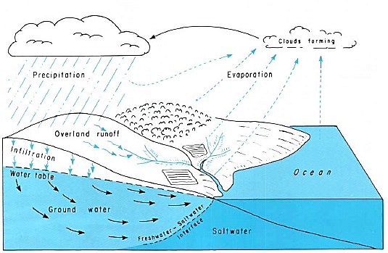

Precipitation

Evaporation

Groundwater

Infiltration

Ocean

Overland run-off

Clouds forming

SYNOPTIC GEOGRAPHY

**Hot deserts, coasts and glacial**: How could processes change?

**Hazards**: how could storms/wildfires change?

**Ecosystems**: how could marine ecosystems be affected?

**Urban climate**: changes to urban rainfall.

**Population, health and well-being**: spread of disease, limits to growth.

**Resources**: water security.



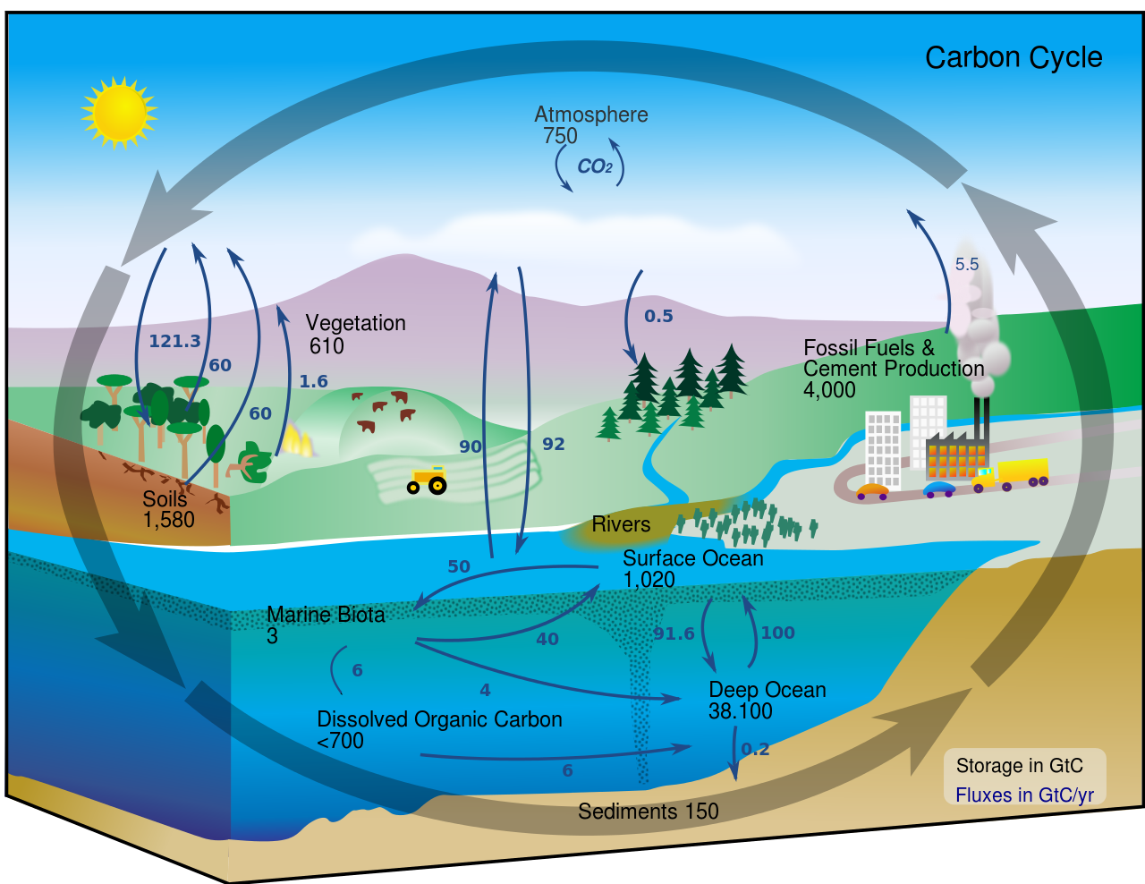



• **Photosynthesis** is the process where green plants and phytoplankton use sunlight to convert CO2 and H2O into glucose and O2 – to produce biomass and for respiration – this is **sequestration**.

• **Respiration** is essentially the reverse of photosynthesis – plants and animals release energy in the process, along with CO2.

• **Decomposition:** When living things die, their biomass is broken down by **decomposers**. Much of the material is respired if there is enough oxygen, but CH4 is produced in limited oxygen. Not all matter is decomposed – becoming soil humus.

• **Combustion** releases stored biomass into the atmosphere – e.g. from trees and plants through wildfires.

• **Weathering –** the breakdown of carbonate rock by acidic rainwater which release bicarbonate ions – to later re-form limestone.

• Humans are releasing huge amounts of CO2 through land-use change, deforestation, and fossil fuel combustion (transport, cooking, and electricity). This dwarfs volcanic activity.

• Farming releases CH4 through livestock and rice farming, and CO2 from ploughing.

• Humans are also increasing the number of wildfires – both deliberately (through rainforest clearance, poaching) and accidentally.

• Deforestation releases the carbon stored as biomass.

• As population grows and countries develop, the pressures on the land and resources increase!

PROCESSES WITHIN THE CARBON CYCLE

CHANGES TO THE CARBON CYCLE

THE CARBON BUDGET

The difference between inputs and outputs. Change from natural processes to human changes. Humans are changing the stores and fluxes – decreased stores of fossil fuels – increased atmospheric and dissolved oceanic carbon.

Changing the budget can have feedback loops (+ve and -ve).

Land:

More CO2 = more plant growth -> decrease in CO2 (-ve feedback)

More CO2 = melting of permafrost -> release of methane (+ve feedback)

Knock-on effects on weather and droughts, agriculture, and ecosystems.

Oceans:

Thermal expansion and melting land ice cause sea level to rise. Acidification from dissolved CO2 – coupled with increased temperatures – is disastrous for coral reefs. Reduced albedo from melting ice -> decreases albedo -> more warming (+ve feedback).

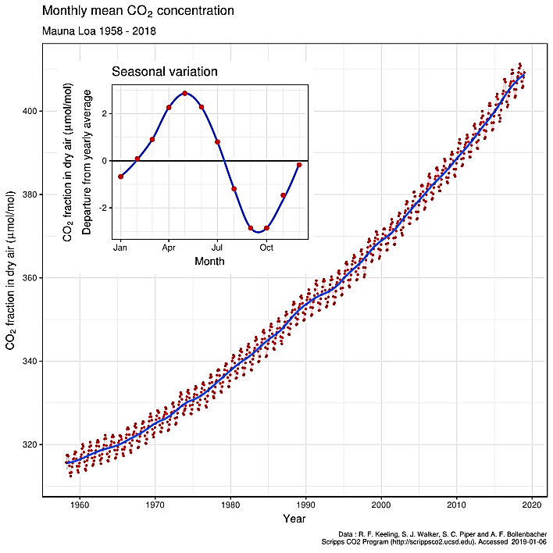

THE FAST AND SLOW CARBON CYCLES

• Carbon can either be organic (from living things), or **inorganic** – from rock.

• The carbon cycle is a   
continuous **process**.

• There are essentially two carbon cycles – the **fast** carbon cycle (months to years) and the **slow** carbon cycle (hundreds of   
years to millennia).

• The fast carbon cycles transfer CO2 between the oceans and **atmosphere** (oceanic inorganic carbon pump), and living things quickly store and release carbon.

• The slow carbon cycle includes the formation of **rock**, including burial and compaction of ocean sediments, and the release of CO2 from the mantle to the atmosphere by volcanic activity.

• **Humans** are very good at altering the carbon cycle.

SYNOPTIC GEOGRAPHY

**Hot deserts, coasts and glacial**: how could processes change?

**Antarctica**: how could climate change increase vulnerability?

**Urban climate**: the urban heat island.

**Population, health and well-being**: spread of disease, limits to growth.

**Resources**: energy security and the use of fossil fuels and renewables.

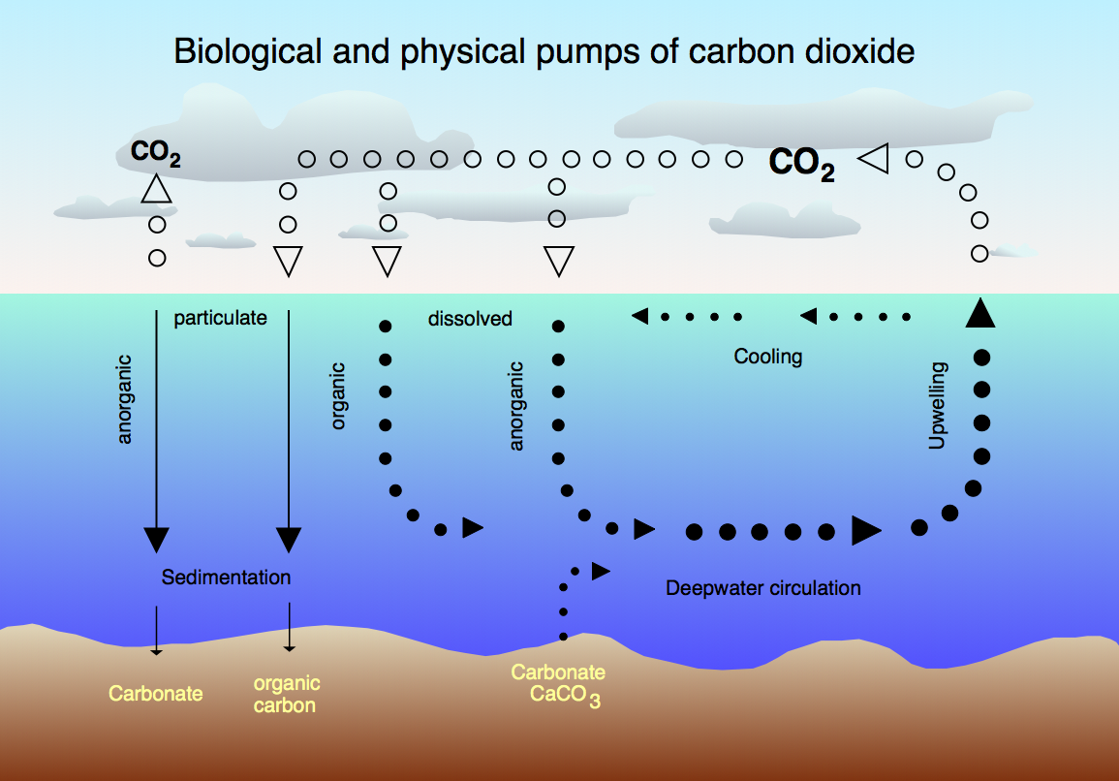

Equator

Poles

THE ENHANCED GREENHOUSE EFFECT

• Gases such as CO2 and CH4 are greenhouse gases. They warm the planet by reabsorbing outgoing radiation and   
re-emit the radiation in all directions.

• The greenhouse effect is a natural process, but we’re increasing the concentration of greenhouse gases – that’s why it’s the enhanced greenhouse effect. We’re causing radiative forcing: the difference between incoming and outgoing radiation.



The CARBON CYCLE

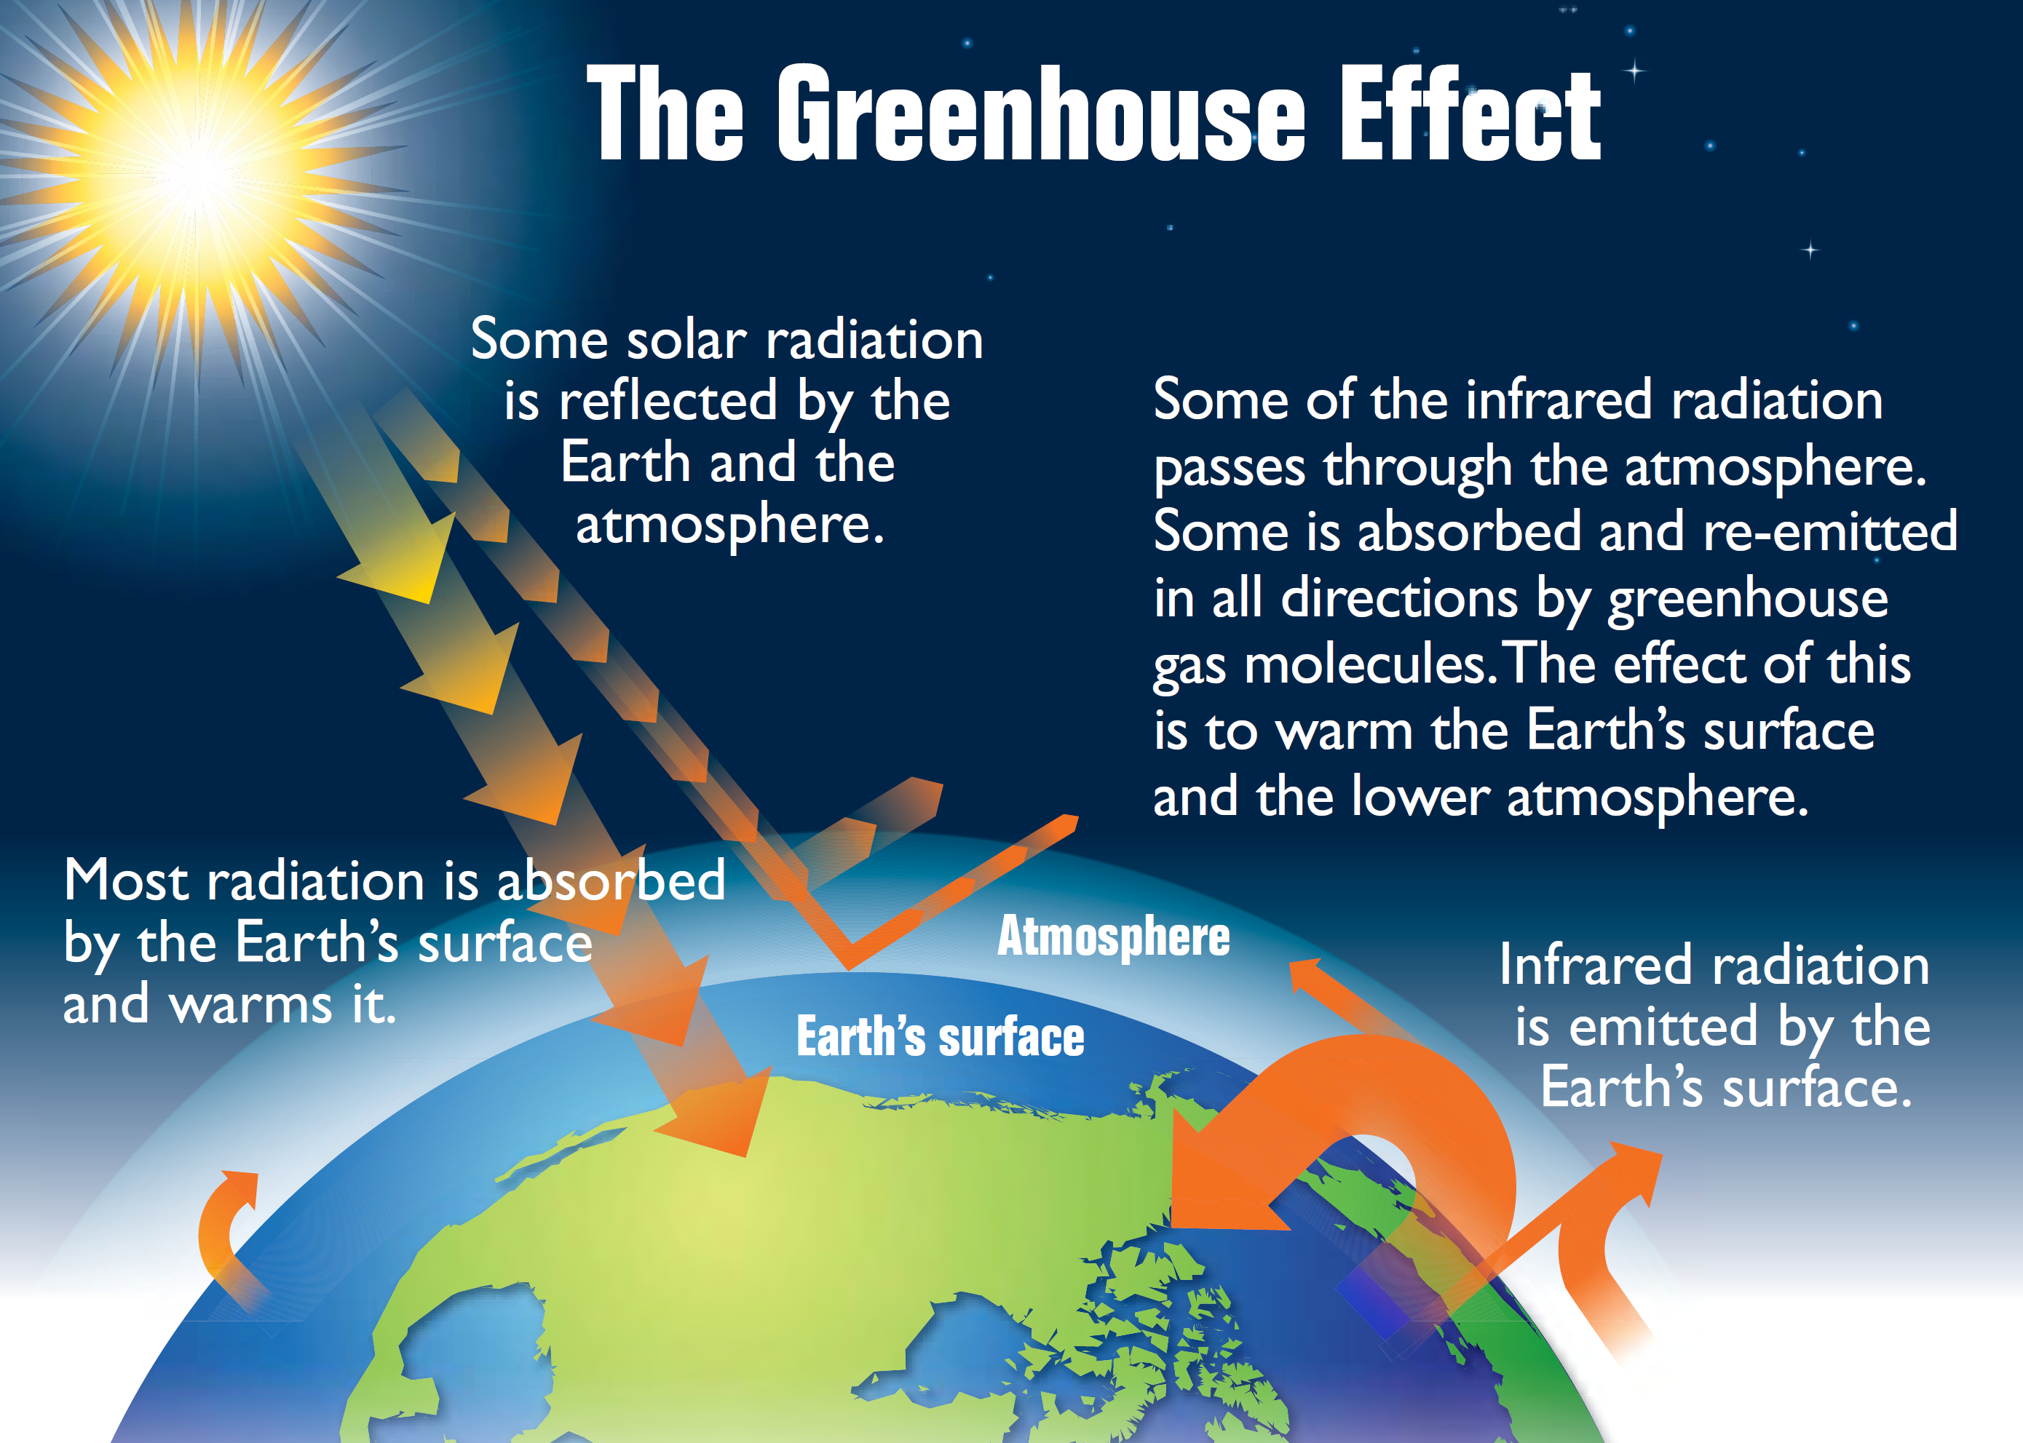

WHAT ARE SYSTEMS?

Most systems are driven by the Sun. Systems are either open or closed.

Open systems have inputs and outputs of energy and material. Closed systems only transfer energy in and out.

The water cycle is a closed system overall, but small-scale drainage basins are open systems.

There are four linked open systems – the atmosphere, the hydrosphere (water), the lithosphere (rock) and the biosphere (living world).

If the inputs and outputs are balanced, the system is in a state of dynamic equilibrium.

Processes called feedback change the equilibrium – positive feedback pushes the system away from the previous equilibrium and negative feedback restores the system back towards the previous equilibrium.

**Stores (components) and flows (transfers) and processes**

**Inputs**

**Outputs**



WHERE’S THE CARBON?

**Stores** of carbon are measured in gigatonnes. **Sinks** absorb more than they emit, sources of carbon release the carbon faster than they absorb carbon.

The movement between the stores (**fluxes**) is measured in   
gigatonnes per year.

Atmospheric CO2 is measured in ppm – parts per **million**.

**Hydrosphere** – dissolved CO2 in oceans, and living animals and plants within the oceans

**Atmosphere** – gaseous CO2 – from natural and human sources

**Biosphere** – living plants and animals, soil litter and soil organic carbon, and peat

**Cryosphere** – organic matter locked up in permafrost – frozen ground

**Lithosphere** – carbonate rocks, fossil fuels (kerogens) and marine sediments



REDUCING OUR IMPACT

There are strong links between the water and carbon cycles, and both are vital for life on Earth. We’re causing changes, and we need to limit the effects because of the positive feedback cycles that warming has.

For example, we can:

✓ Increase our use of renewable electricity generation, and use alternative or more efficient transport.

✓ Reduce CO2 emissions by using CCS – carbon capture and storage.

✓ Reduce emissions from land-use change and agriculture – less cattle farming and less ploughing.

✓ Reduce emissions globally – international trading schemes (e.g. Paris and Kyoto agreements), with implementation at both national and local levels.

