Year 13 BTEC Business Revision Resources

Unit 3 Personal and Business Finance
Past Papers and Mark Schemes
Filter by External Assessments, then Unit 3
Unit 3 Past Papers

Tutor2U YouTube Channel
Link to Videos
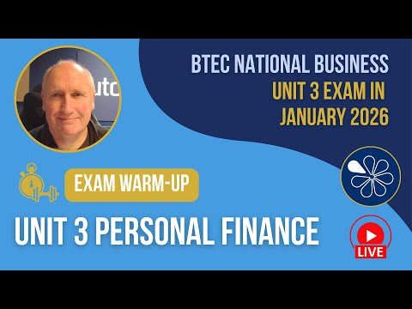

Unit 6 Principles of Management
Past Papers and Mark Schemes
Filter by External Assessments, then Unit 6
Unit 6 Past Papers

Tutor2U YouTube Channel
Link to Videos
